COMPREHENSIVE SEO AUDIT

Odyssey Nurseries
www.odysseynursery.com

Technical Audit · On-Page Analysis · Content Strategy
Competitive Landscape · Local SEO · Performance Optimization

PREPARED: FEBRUARY 2026
CONFIDENTIAL
1. EXECUTIVE SUMMARY
A comprehensive SEO audit was conducted to evaluate odysseynursery.com's technical health, on-page optimization, content strategy, competitive positioning, and local SEO readiness. This audit goes beyond surface-level crawl checks to provide actionable, prioritized recommendations that will directly impact organic visibility, search rankings, and enrollment conversions.

+Key Findings at a Glance

5  Critical Issues | 8  High Priority Issues | 12+  Growth Opportunities

The site currently ranks well for its branded term and the niche query “Reggio Emilia nursery Dubai,” but is completely invisible for high-volume commercial keywords such as “best nursery in Dubai,” “nursery fees Dubai,” and location-specific queries like “nursery JBR” or “nursery Meydan.” With only 20–25 indexable pages, the site is competing against rivals with 50–100+ pages of optimized content. The technical foundation has several critical flaws—including a broken internal link pattern across all location pages, an HTTP link in the global navigation, and zero structured data markup—that undermine both crawl efficiency and search visibility.

The opportunity is substantial. Fixing the technical issues alone will improve crawl health and trust signals. Expanding the content footprint with a targeted blog, dedicated fee pages, and enriched location pages could realistically 3–5x the site’s organic keyword coverage within 6–9 months. Implementing LocalBusiness schema across all branches will unlock Google’s Local Pack, where the vast majority of nursery enrollment decisions begin.

2. CURRENT SEARCH VISIBILITY & RANKINGS
The following data represents a snapshot of Odyssey Nursery’s current organic visibility based on live SERP analysis conducted in February 2026. This baseline establishes where the site stands today and provides a benchmark for measuring improvement.

2.1 SERP Position Map — Key Commercial Queries

Target Keyword | Position | Ranking URL | Assessment
nursery Reggio Emilia Dubai | #1 | Homepage | ✅ Strong — Brand-aligned niche term
best nursery Dubai | Not in Top 20 | Not ranking | ❌ Invisible for highest-volume query
best nursery Dubai 2025 | Not in Top 20 | Not ranking | ❌ Dominated by competitors + aggregators
nursery JBR Dubai | #8–10 | /location/jbr/ | ⚠️ Bottom of page 1, behind 7 competitors
nursery Meydan Dubai | ~#3–5 | /location/meydan/ | ⚠️ Low volume term, thin page content
nursery fees Dubai | Not ranking | No fee page exists | ❌ High-intent query, zero content
nursery Umm Suqeim | ~#5–8 | /location/umm-suqeim-2/ | ⚠️ Thin content, duplicate meta tags
spring camp Dubai nursery | Not in Top 10 | /bloom-from-within/ | ❌ Same title/desc as homepage

Overall Keywords Report:
Keyword | Position | Search Volume | Keyword Difficulty | CPC
pre schools in dubai | 1 | 30 | 41 | 2.43
winter camp dubai | 6 | 40 | 13 | 0
nursery in uae | 6 | 50 | 41 | 0
odyssey plaza | 69 | 40 | 5 | 0
best preschool in dubai | 48 | 50 | 23 | 0
best nursery in dubai | 25 | 90 | 24 | 0
uae nurseries | 19 | 40 | 15 | 0
dubai nursery schools | 4 | 30 | 21 | 2.43
nursery in uae | 12 | 50 | 41 | 0
preschool in dubai | 11 | 30 | 48 | 2.43
dubai nursery | 4 | 30 | 51 | 2.43
affordable nursery in dubai | 43 | 70 | 9 | 0
nursery jumeirah | 14 | 50 | 50 | 0
nursery jumeirah | 36 | 50 | 50 | 0
preschools in dubai | 11 | 30 | 40 | 2.43
nurseries in dubai | 20 | 70 | 36 | 0
nursery in dubai | 12 | 140 | 54 | 0
uae nursery | 10 | 40 | 43 | 0
nursery dubai | 6 | 40 | 54 | 2.43
nursery schools in dubai | 17 | 40 | 35 | 0
day care in dubai | 9 | 40 | 46 | 1.38
day care in dubai | 10 | 40 | 46 | 1.38
best nurseries in dubai | 22 | 70 | 22 | 0
pre schools in dubai | 6 | 30 | 41 | 2.43
dubai nursery fees | 65 | 40 | 6 | 0
nursery school abu dhabi | 39 | 40 | 28 | 0
nursery uae | 7 | 90 | 52 | 0
kindergarten dubai | 20 | 70 | 38 | 0

2.2 Google Index Health
odysseynursery.com search reveals approximately 20–25 indexed pages. For a multi-location nursery brand with 12 branches, this is an extremely thin footprint. By comparison, competitors like Yellow Kite Nursery & Blossom Nursery and Toddler Town have 40–80+ indexed pages.

Metric | Odyssey (Current) | Industry Benchmark
Indexed Pages | ~20–25 | 40–80+
Pages with Content >500 words | ~4–5 | 20–40+
Blog/Resource Pages | 0 | 15–30+
Location Pages (unique content) | 0 of 12 | All with unique content
Schema Markup Pages | 0 | All key pages

2.3 Domain Authority & Backlink Profile

S. No | Authority | Score | Note
1 | Domain Authority | 22 | Domain authority is below the industry benchmark. Strengthening high-quality backlinks, topical authority content, and a digital PR strategy is required to improve domain trust and ranking potential.
2 | Page Authority | 32 | Page authority is moderate but can be improved. Optimize internal linking, build targeted backlinks to priority pages, and enhance content depth for ranking pages.
3 | Semrush Authority Score | 28 | Authority score indicates average competitive strength. A structured link-building campaign and improved content signals can increase a domain's overall competitiveness.
4 | Total Backlinks | 3K | Total backlink count is decent; however, link quality needs improvement. Focus should shift from quantity to high-authority, relevant backlinks.
5 | Quality Backlinks | 271 | Only a small portion of backlinks are high-quality. Increase backlinks from authoritative and relevant industry domains to improve trust signals.
6 | % Quality Backlinks | 8% | The quality backlink ratio is low. Aim for at least 20–30% quality backlinks for stronger domain authority growth.
7 | DoFollow Backlinks | 70% | Healthy DoFollow ratio supports authority building. Continue acquiring natural DoFollow links from relevant sources.
8 | NoFollow Backlinks | 30% | Balanced NoFollow profile maintains natural link diversity. Ensure NoFollow links come from reputable platforms.
9 | Spam Score | 1% | Very low spam score indicates a clean backlink profile. Continue monitoring toxic links regularly to maintain domain health.
10 | Moz Trust | 3 | Moz Trust is low, indicating limited trust signals from authoritative domains. Improve by acquiring backlinks from trusted, high-domain websites.
11 | Off-page SEO Score | 38% | Off-page SEO performance is below optimal levels. A consistent outreach, citation building, and digital PR campaign are required to improve the score.
12 | Domain Age | 12 Years 251 Days | Strong domain age provides a credibility advantage. Leveraging this maturity with strategic SEO can significantly improve rankings.

Overall Backlink Report: Click Here

2.4 Core Web Vitals & Page Speed
Home Core Web Vitals Report:
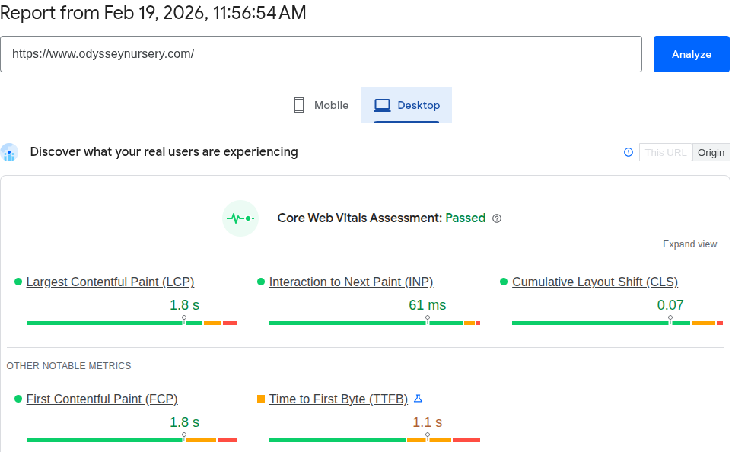
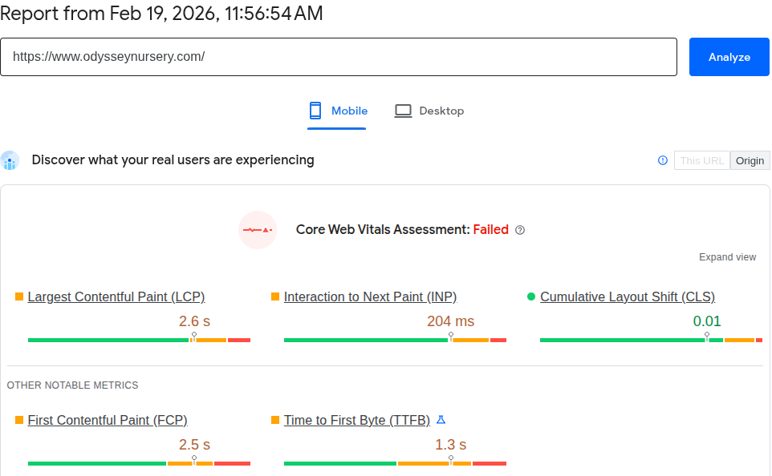

Home Page Performance Report:
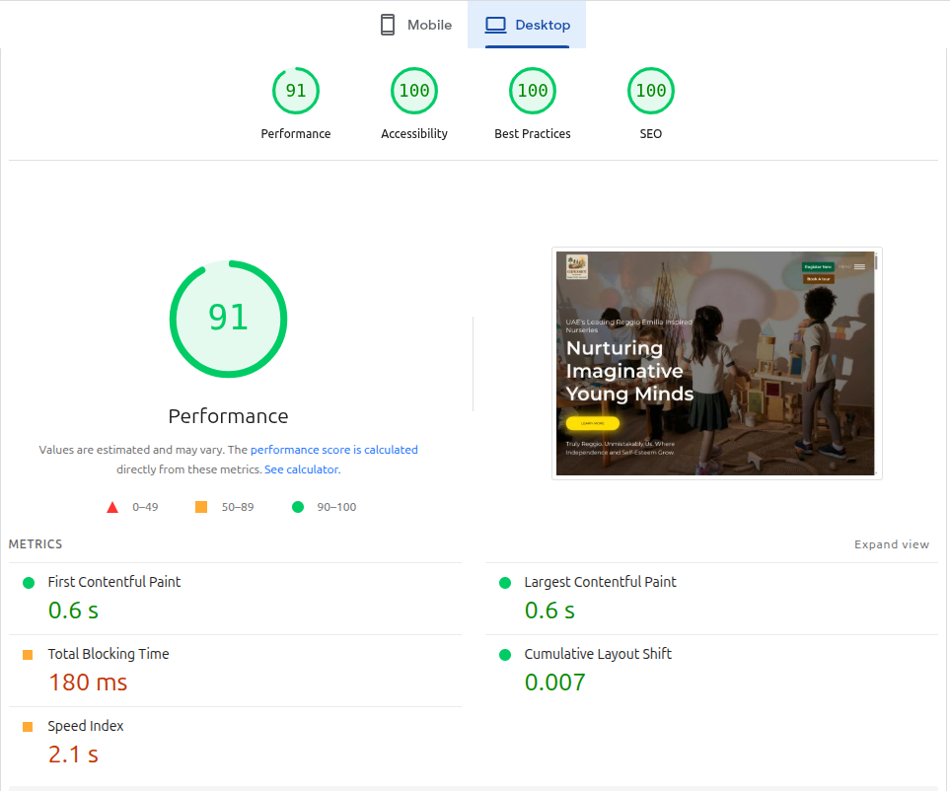

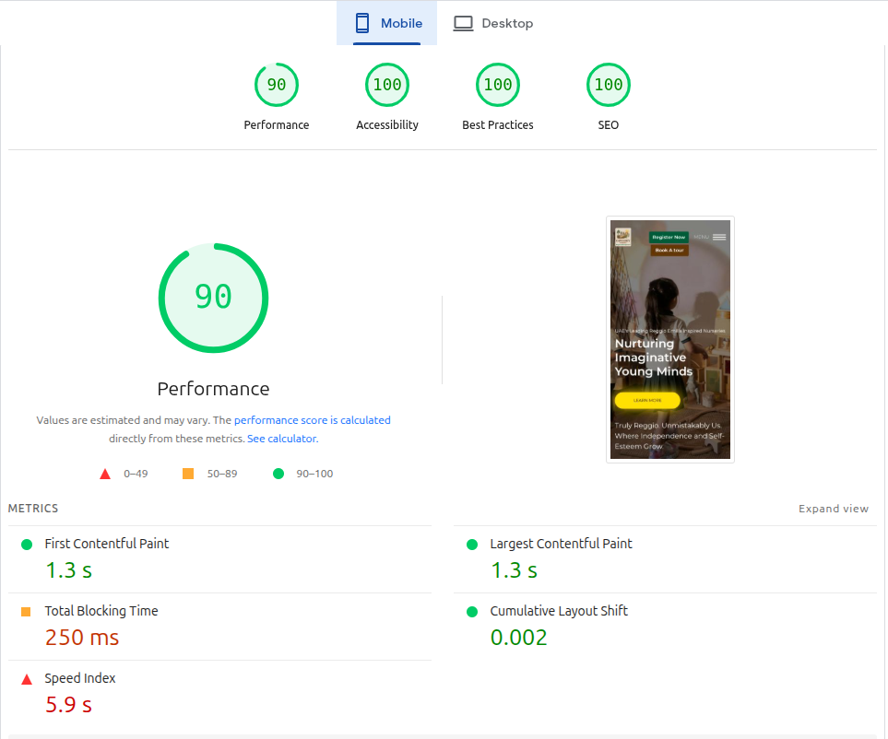

3. TECHNICAL SEO AUDIT
This section covers all technical issues discovered during the crawl and manual review. Each issue is classified by priority and includes the root cause, SEO impact, and specific fix required.

3.1 Critical Issues

ISSUE T-1: HTTP Link in Global Navigation (Every Page)
The “Book a Tour” link in the menu section of the main navigation menu points to odysseynursery.com/#form (no HTTPS). Because this link is in the header, it appears on every single page of the site. This creates a mixed-content signal, triggers browser security warnings, and splits link authority between the HTTP and HTTPS versions of the domain.
Impact: Site-wide trust signal degradation, potential browser warnings, crawl bifurcation.
Fix: Update the nav menu link to https://www.odysseynursery.com/#form.

ISSUE T-2: Zero Structured Data / Schema Markup
The site has absolutely no structured data markup. For a multi-location childcare business, this is a critical gap. Missing schema types include:
- LocalBusiness / ChildCare schema for each of the 12 branch locations
- Website Schema on the all pages
- Product Schema for all pages
- Educational Organization schema on the About page
- Breadcrumb List schema for navigation hierarchy
- FAQ schema for parent information content
- AggregateRating / Review schema for testimonials
Impact: No eligibility for rich snippets, knowledge panels, or Local Pack features. Competitors with schema markup get significantly higher click-through rates from SERPs.
Fix: Implement JSON-LD schema on each page type. Use Google’s Structured Data Testing Tool to validate.

ISSUE T-3: H1 Tags Misused as CTA Instead of Page Topic
Four core pages (About, Environment, Parent Info, Age Groups) use “Request Tours & Information” as their H1 tag. The H1 should communicate the primary topic of the page to search engines. Using a generic CTA form title as the H1 fundamentally misrepresents what each page is about and throws away the most valuable on-page SEO signal.
Impact: Search engines cannot identify page topics; reduces relevance for target keywords.
Fix: Replace each H1 with a unique, keyword-rich heading that describes the page content. Move the form CTA to an H2 or lower.

ISSUE T-4: Duplicate Meta Titles Across 5 Abu Dhabi Location Pages
West Yas, Saadiyat, Al Muneera, Khalifa City A, and Al Zeina all share the identical title “Discover Odyssey Nursery’s Khalifa City A Location Today” — note this is the Khalifa City title being used for all five different locations. The same issue affects meta descriptions. Google interprets these as duplicate/low-quality pages and may suppress them from indexing entirely.
Impact: 5 location pages competing with each other for the same signals; possible indexing suppression.
Fix: Write unique, location-specific titles and descriptions for each branch (e.g., “Odyssey Nursery Saadiyat Island | Reggio Emilia Nursery Abu Dhabi”).

ISSUE T-5: 60+ Oversized, Unoptimized Images
The site serves 60+ images that are not optimized for web delivery. Highlights include:
- 2 homepage PNGs at 1.2MB each (should be <100KB as WebP)
- Spring camp hero image at 1.53MB
- Location hero images ranging from 500KB to 740KB
- No WebP/AVIF format serving detected
- No lazy loading implementation observed
- No responsive srcset attributes for different screen sizes
Total estimated excess image weight: ~15MB+ across the site, where best practice would be under 3MB total.
Impact: Severely degraded LCP (Largest Contentful Paint), poor Core Web Vitals scores, and higher bounce rates on mobile.
Fix: Convert all images to WebP, compress them to the appropriate quality, implement lazy loading, and add srcset for responsive delivery. Use a WordPress plugin like ShortPixel or Imagify for automated optimization.

3.2 High Priority Issues

ISSUE T-6: External Links Returning 302 Redirects (Instagram & WhatsApp)
All Instagram profile links and WhatsApp links across the Contact and Location pages return 302 temporary redirects. While these are external links, the volume (contributing to the 116 total 3xx redirects) creates unnecessary redirect chains. Update all external links to their final destination URLs.

ISSUE T-7: Missing XML Sitemap Optimization
While WordPress likely generates a default sitemap, there’s no evidence of a properly segmented, submitted sitemap. The sitemap should be structured with separate entries for location pages, core pages, and any future blog content. Submit to Google Search Console with proper priority and change frequency signals.

ISSUE T-8: No Robots.txt Optimization
No custom robots.txt directives were identified. The robots.txt should explicitly reference the sitemap location and block any low-value pages from crawling (e.g., tag archives, search results pages, staging URLs).

ISSUE T-9: Spring Camp Page Shares Homepage Meta Tags
The /bloom-from-within-spring-camp/ page uses the identical title and meta description as the homepage. This seasonal landing page should have its own optimized meta tags targeting queries like “spring camp Dubai nursery,” “educational spring camp Dubai 2026,” and “kids spring camp Dubai.”

ISSUE T-10: Orphan Landing Page (/reggio-nursery-lp/)
A substantial landing page with staff bios and detailed curriculum information exists at /reggio-nursery-lp/ but is not linked from the main navigation. It appears in Google search results, meaning crawl budget is spent indexing a page that users can’t naturally discover. This content should either be integrated into the main site structure or properly linked.

ISSUE T-11: No Internal Linking Strategy
Pages operate in silos with minimal cross-linking. Location pages don’t link to age groups. Age groups don’t link to specific locations. The About page doesn’t reference the Environment page. This flat, disconnected structure prevents link equity from flowing between pages and makes it harder for Google to understand topical relationships.

ISSUE T-12: Canonical Tags Review

S. No | Address | Occurrences | Indexability | Canonical URL
1 | https://www.odysseynursery.com/ | 1 | Indexable | https://www.odysseynursery.com/
2 | https://www.odysseynursery.com/cookie-policy/ | 1 | Indexable | https://www.odysseynursery.com/cookie-policy/
3 | https://www.odysseynursery.com/parent-info/ | 1 | Indexable | https://www.odysseynursery.com/parent-info/
4 | https://www.odysseynursery.com/age-groups/ | 1 | Indexable | https://www.odysseynursery.com/age-groups/
5 | https://www.odysseynursery.com/about/ | 1 | Indexable | https://www.odysseynursery.com/about/
6 | https://www.odysseynursery.com/environment/ | 1 | Indexable | https://www.odysseynursery.com/environment/
7 | https://www.odysseynursery.com/privacy-policy/ | 1 | Indexable | https://www.odysseynursery.com/privacy-policy/
8 | https://www.odysseynursery.com/virtual-tours/ | 1 | Indexable | https://www.odysseynursery.com/virtual-tours/
9 | https://www.odysseynursery.com/terms-and-conditions/ | 1 | Indexable | https://www.odysseynursery.com/terms-and-conditions/
10 | https://www.odysseynursery.com/contact-us/ | 1 | Indexable | https://www.odysseynursery.com/contact-us/
11 | https://www.odysseynursery.com/location/ | 1 | Indexable | https://www.odysseynursery.com/location/
12 | https://www.odysseynursery.com/bloom-from-within-spring-camp/ | 1 | Indexable | https://www.odysseynursery.com/bloom-from-within-spring-camp/
13 | https://www.odysseynursery.com/location/burjalarab/ | 1 | Indexable | https://www.odysseynursery.com/location/burjalarab/
14 | https://www.odysseynursery.com/location/al-zeina/ | 1 | Indexable | https://www.odysseynursery.com/location/al-zeina/
15 | https://www.odysseynursery.com/location/city-walk/ | 1 | Indexable | https://www.odysseynursery.com/location/city-walk/
16 | https://www.odysseynursery.com/location/meydan/ | 1 | Indexable | https://www.odysseynursery.com/location/meydan/
17 | https://www.odysseynursery.com/location/khalifa-city-a/ | 1 | Indexable | https://www.odysseynursery.com/location/khalifa-city-a/
18 | https://www.odysseynursery.com/location/umm-suqeim-2/ | 1 | Indexable | https://www.odysseynursery.com/location/umm-suqeim-2/
19 | https://www.odysseynursery.com/location/mushrif/ | 1 | Indexable | https://www.odysseynursery.com/location/mushrif/
20 | https://www.odysseynursery.com/location/jumeirah-beach-residences/ | 1 | Indexable | https://www.odysseynursery.com/location/jumeirah-beach-residences/
21 | https://www.odysseynursery.com/location/living-legends/ | 1 | Indexable | https://www.odysseynursery.com/location/living-legends/
22 | https://www.odysseynursery.com/location/al-muneera/ | 1 | Indexable | https://www.odysseynursery.com/location/al-muneera/
23 | https://www.odysseynursery.com/location/west-yas/ | 1 | Indexable | https://www.odysseynursery.com/location/west-yas/
24 | https://www.odysseynursery.com/location/saadiyat/ | 1 | Indexable | https://www.odysseynursery.com/location/saadiyat/

ISSUE T-13: No Hreflang Tags for Multi-Language Content
Odyssey offers French and Arabic programs but has no French or Arabic web content and no hreflang tags. This is a missed opportunity for the French-speaking and Arabic-speaking parent populations in Dubai and Abu Dhabi.

Suggestion:
<link rel="alternate" hreflang="en-ae" href="https://www.odyssey nursery.com/en/" />
<link rel="alternate" hreflang="ar-ae" href="https://www.odyssey nursery.com/ar/" />
<link rel="alternate" hreflang="fr-ae" href="https://www.odyssey nursery.com/fr/" />
<link rel="alternate" hreflang="x-default" href="https://www.odyssey nursery.com/" />

4. ON-PAGE SEO ANALYSIS
This section evaluates the quality and optimization of the site’s existing content, page by page.

4.1 Page-by-Page Assessment

Page | Title | H1 | Meta Desc | Notes
Homepage | ⚠ Too long | ✅ Good | ⚠ Weak / Generic | Lacks strong keyword targeting (e.g., “nursery in Dubai”); no structured value proposition
About | ⚠ Too long | ❌ CTA as H1 | ⚠ Too long | H1 appears marketing-driven rather than topic-driven; limited keyword targeting
Age Groups | ⚠ Slightly long | ❌ CTA as H1 | ✅ OK | Good structural intent but missing keyword variants (preschool, early years, etc.)
Curriculum / Approach | ⚠ Moderate | ⚠ Generic | ⚠ Generic | Reggio Emilia mentioned but not deeply optimized for related search terms
Environment / Campus | ✅ OK | ⚠ Weak | ⚠ Missing optimization | Content present but lacks keyword depth and semantic richness
Locations Hub | ❌ Too short | ✅ OK | ⚠ Too long | Title only 26 chars: 'Locations Archive - Odyssey'
5 Abu Dhabi Locations | ❌ All duplicate | ✅ OK | ❌ All duplicate | All say 'Khalifa City A' regardless of location
Spring Camp | ❌ Duplicate | ⚠ Double H1 | ❌ Duplicate | Same title/desc as homepage + 2 H1 tags
Individual Location Pages | ⚠ Repetitive | ✅ OK | ❌ Duplicate / Similar | Content largely templated; minimal local keyword variation

Key Observations

1. Title Tag Optimization
- Several pages have overly long titles
- Titles lack strong commercial keyword targeting
- Location pages do not consistently include “nursery in [area]” format
- There is some duplication risk between seasonal pages and the homepage

2. H1 Structure Issues
- Some pages use CTAs instead of topic-based H1s
- Certain pages contain generic H1s not aligned with search intent
- Minor double-H1 risk on seasonal pages
Best practice:
Each page should have one keyword-focused H1, followed by structured H2/H3 sections.

3. Meta Description Optimization
- Several meta descriptions are generic
- Weak commercial intent signals
- No emotional hook for parent audience
- Missing location and trust signals
Meta descriptions should:
- Include location modifiers
- Include emotional reassurance
- Include enrollment CTA

4.2 Content Depth Assessment
Odyssey’s content structure is currently homepage-weighted, with limited depth across supporting pages.

Content Imbalance
- Homepage: Moderate depth
- Age Groups: Decent structural base
- Location Pages: Thin and templated
- Curriculum Page: Surface-level explanation
- Blog Section: Not present
- Admissions / Fees: Not present
Odyssey’s content structure is currently homepage-weighted, with limited depth across supporting pages.

Location Pages – Major Gap
Current issues:
- 250–400 words average
- Template-style repetition
- Limited local keyword insertion
- No neighborhood-specific information
- No local testimonials per branch
- No campus-specific FAQ
Google’s Helpful Content system deprioritizes pages that:
- Offer boilerplate copy
- Provide little differentiation
- Lack unique value per location

Internal Linking Depth
- Limited contextual internal linking
- Location pages not strongly interlinked
- No blog hub structure (currently)

4.3 Overall On-Page SEO Health Summary

Strengths
✔ Clear brand positioning
✔ Clean site structure
✔ Reggio Emilia differentiation

Weaknesses
✖ Thin location content
✖ No blog ecosystem
✖ Missing commercial landing pages (fees/admissions)
✖ Generic meta descriptions
✖ Weak keyword optimization depth
✖ Improper H1 Optimization Across Core Pages
✖ Duplicate Meta Titles & Descriptions (Location Pages)
✖ No Commercial Landing Pages (Fees / Admissions)
✖ Weak Internal Linking Structure
✖ No FAQ Schema or Rich Snippet Optimization
✖ Limited Semantic Keyword Coverage
✖ Homepage Keyword Targeting Not Fully Optimized
✖ No Trust Signal Reinforcement on Key Pages
✖ No Content Clustering Strategy
✖ Seasonal Page Optimization Issues
✖ Lack of Conversion-Focused Copy in Meta Descriptions

5. COMPETITIVE LANDSCAPE ANALYSIS
Odyssey Nursery competes in a crowded Dubai early-education market. This section maps the competitive landscape across organic search, content strategy, and local SEO.

5.1 Competitor Content Comparison

Competitor | Blog | Fee Page | Schema | Locations | Est. Pages | Key Advantage
Odyssey | ❌ No | ❌ No | ❌ No | 8 (thin) | ~12 | Reggio Emilia niche
Discovery Nursery | ✅ Yes | ⚠ Partial | ⚠ Basic | 2(rich) | ~30+ | Curriculum-focused
Little Haven | ⚠ Limited | ❌ No | ❌ No | 1 (rich) | ~20+ | Boutique positioning
Blossom Nursery | ✅ Yes | ✅ Yes | ✅ Yes | 10+(rich) | ~90+ | Large-scale premium
Yellow Kite | ✅ Yes | ✅ Yes | ✅ Yes | 1 (rich) | ~40+ | SEO content + Reggio
Toddler Town | ✅ Yes | ✅ Yes | ✅ Yes | 2 (rich) | ~50+ | Award branding
Little Dreamers | ✅ Yes | ✅ Yes | ⚠ Partial | 1 (rich) | ~35+ | Award-winning brand
JINS | ✅ Yes | ✅ Yes | ✅ Yes | 5 (rich) | ~80+ | Scale + content depth
British Orchard | ✅ Yes | ✅ Yes | ✅ Yes | 10+ (rich) | ~100+ | Massive footprint

5.2 Key Competitor Insight

Overview
The competitive landscape in the UAE nursery sector is dominated by brands that combine strong curriculum positioning with structured SEO execution. While Odyssey Nursery has a clear Reggio Emilia niche, competitors are outperforming primarily due to deeper content ecosystems, stronger local optimization, and better commercial keyword targeting.

Strategic Observations

1. Content Depth Advantage
Top competitors such as British Orchard, Blossom, and JINS have significantly larger content footprints. They maintain:
- Dedicated blog sections
- Detailed curriculum pages
- Separate fee/pricing pages
- Expanded location landing pages
This content depth strengthens their topical authority and organic ranking coverage.

2. Strong Local SEO Execution
Competitors with multiple branches have:
- Individual optimized pages per location
- Location-specific keyword targeting
- Strong Google Business Profile optimization
- Higher review volumes
This gives them consistent Local Pack visibility across Dubai and Abu Dhabi.

3. Commercial Intent Capture
Several competitors rank for high-conversion keywords such as:
- nursery fees Dubai
- best nursery in Dubai
- nursery admission Dubai
Odyssey currently lacks dedicated landing pages targeting these high-intent searches, limiting organic lead generation.

4. Brand Trust & Authority Signals
Top-performing nurseries strengthen credibility through:
- Awards & accreditations pages
- Detailed KHDA information
- Testimonials & review-rich content
- Strong backlink profiles
These signals increase both search engine trust and parent confidence.

5. Structured Schema Implementation
Leading competitors utilize structured data (LocalBusiness, FAQ, Organization schema), enhancing their visibility in rich results and improving click-through rates.

Competitive Position Summary
Odyssey Nursery has strong brand positioning and curriculum clarity. However, competitors outperform primarily due to:
- Greater content volume
- Stronger local SEO optimization
- Better commercial keyword capture
- Higher review acquisition
- Structured technical implementation
With strategic SEO expansion and structured content growth, Odyssey can realistically close this gap within 3–6 months.

5.3 Keyword Gap Analysis
Based on SERP analysis, the following high-value keywords have search volume but zero Odyssey content:

High-Intent Commercial Keywords
Keyword Opportunity | Est. Volume | Current Ranking | Content Needed
best nursery in Dubai | High | Not ranking | Authority landing page + blog support
nursery fees Dubai 2026 | High | No page exists | Dedicated fees/pricing page
nursery school in Dubai | High | Page 3+ / Weak | Homepage optimization
preschool Abu Dhabi | High | Not ranking | Location-based landing page
nursery admission Dubai | High | Not ranking | Admissions guide page
affordable nursery Dubai | Medium | Not ranking | Value positioning page
British curriculum nursery Dubai | Medium | Weak | Curriculum comparison page

Local Search Keyword Gaps
Keyword Opportunity | Est. Volume | Current Ranking | Content Needed
nursery near me | High (each area) | Thin presence | Enriched location pages
nursery in JBR | High | Weak | 800+ word optimized page
nursery in Meydan | Medium | Weak | Expanded local content
nursery in Downtown Dubai | Medium | Not ranking | New location page
nursery in Palm Jumeirah | Medium | Not ranking | Local SEO landing page
nursery Abu Dhabi near me | High | Not ranking | Local schema + page

Informational & Parent Research Keywords
Keyword Opportunity | Est. Volume | Current Ranking | Content Needed
What is Reggio Emilia approach? | Medium | Not ranking | In-depth guide blog
nursery vs daycare Dubai | Medium | Not ranking | Comparison article
when to start nursery UAE | Medium | Not ranking | Parenting advice blog
benefits of play-based learning | Medium | Not ranking | Educational blog
how to choose a nursery in Dubai | Medium | Not ranking | Pillar blog post

Trust & Authority Keywords
Keyword Opportunity | Est. Volume | Current Ranking | Content Needed
KHDA approved nursery Dubai | Medium | Not ranking | Accreditation/trust page
top rated nursery in Dubai | Medium | Not ranking | Review-based authority page
bilingual nursery Dubai French | Medium | Not ranking | French program landing page
Reggio Emilia nursery UAE | Medium | Weak | SEO optimized philosophy page

Strategic Keyword Gap Summary
- Odyssey primarily ranks for branded searches.
- Competitors dominate commercial + local + informational keywords.
- No structured fee page limits commercial conversion queries.
- Thin location content weakens “near me” rankings.
- Lack of a blog ecosystem reduces topical authority.

6. LOCAL SEO ASSESSMENT
For a multi-location nursery, local SEO is where the majority of enrollment decisions begin. Parents search for “nursery near me” or “nursery in [neighborhood]” and make decisions based on Google Maps results, reviews, and proximity. This section evaluates Odyssey’s local search readiness.

6.1 Google Business Profile Audit
- All locations verified, but optimization levels vary.
- The primary category should be set consistently as Nursery School (avoid mixed categories).
- Several profiles lack fully optimized business descriptions with local keywords.
- Review count significantly lower than top competitors in some locations.
- Inconsistent review response strategy across branches.
- Limited Google Posts activity (low engagement signal).
- Photo count is lower compared to competitors (classroom & activity images needed).
- Q&A section not actively managed or optimized.
- Minor NAP inconsistencies observed across some directories.
- Local Pack visibility is inconsistent across key search terms.

6.2 NAP Consistency Check
NAP (Name, Address, Phone) consistency across the web is a critical local ranking factor. Inconsistent business information across directories confuses Google and dilutes the local authority. The following directories should be audited for consistency:
- Google Business Profile (all 12 branches)
- Bayut.com nursery listings
- Edarabia.com nursery listings
- EdCare.ae listings
- NurseryinDubai.com listings
- Tickikids.com listings
- Facebook Pages for each branch
- Instagram profiles for each branch

6.3 Review Strategy Assessment
Online reviews are a significant local ranking factor and the primary trust signal for parents choosing a nursery. A review acquisition and response strategy should be implemented across all branches.

- Review count varies significantly across branches.
- Some locations have a 50–80 review gap compared to top competitors.
- Average rating strong (4.5★+), but review volume insufficient for dominance.
- Inconsistent review response strategy across branches.
- Limited keyword-rich responses in owner replies.
- Review growth rate appears slow compared to competitors.
- Negative reviews addressed, but responses lack depth and reassurance.

7. CONTENT STRATEGY RECOMMENDATIONS
Overview
Odyssey Nursery currently lacks a cohesive content strategy — no blog, no resource center, no FAQ section, and limited local content on key pages. In comparison, competitors such as British Orchard, Blossom Nursery, JINS Nursery, Yellow Kite, and Toddler Town maintain robust content ecosystems that significantly improve their visibility for both commercial and informational search queries. Closing this gap will be one of the fastest and most impactful ways to improve organic rankings, user engagement, and lead generation.
This strategy is divided into three core phases with a monthly roadmap that aligns with SEO maturity, user intent mapping, and the competitive landscape analysis conducted.

7.1 Phase 1: Foundation Content

1) Expanded Location Pages (All 12 Campuses)
Odyssey’s current location pages are thin compared with competitors. Each campus should be rewritten with unique, 800–1200+ word content that includes:
- Local neighborhood details
- Campus features & facilities
- Staff highlights
- Parent testimonials
- Campus-specific outcomes
- Local FAQs (“nursery in XXX near me”)
This content targets local queries such as:
- nursery in JBR
- best nursery in Meydan
- nursery near Emirates Hills
Competitors like British Orchard and Blossom have enriched location pages driving both local and multi-location visibility.

2) Admissions Guide Page
Parents often search for procedural information, e.g.:
- nursery school admission Dubai
- how to enroll in UAE nursery
- nursery admission requirements UAE
A step-by-step admissions guide with clear visuals, timelines, and downloadable forms will capture high-intent users early in the decision funnel.

3) FAQ Hub with Structured Data
Create a centralized FAQ page optimized with FAQ schema. This should address core parent concerns such as:
- Student-to-teacher ratio
- Age groups served
- KHDA accreditation
- Safety protocols
- Payment plans
- Curriculum details
FAQ schema increases chances of rich results appearance in SERPs.

4) Main Commercial Pages
Nursery Fees & Pricing Page
Parents searching for nursery options increasingly query fee structures before enquiry. We recommend a dedicated fees & pricing landing page optimized for terms such as:
- nursery fees Dubai 2026
- nursery fees in UAE
- nursery cost Dubai
This page must include:
✔ Transparent fee breakdown
✔ Tiered program pricing
✔ Admission fee details
✔ Clear CTAs for enquiries
✔ FAQ related to fees
This directly competes with fee pages from Blossom Nursery, British Orchard, and JINS — all ranking on page 1.

7.2 Phase 2: Educational Blog Launch
Competitor blogs drive a major portion of their non-brand traffic. Odyssey currently has zero blog content — this represents a massive opportunity to capture discovery traffic and build topical authority.

Blog Publishing Plan (Month 2–4)
Publish 2–4 posts per month, beginning with the most strategic topics:
- What Is the Reggio Emilia Approach? A Complete Guide for UAE Parents
Competitor gap: most competitors superficially mention the philosophy without deep targeting keywords.
- Nursery vs Daycare in Dubai: Which Is Right for Your Child?
Addresses a common pre-purchase comparison query.
- When Should Your Child Start Nursery in the UAE?
High-value informational query with strong conversion potential.
- 7 Signs of a High-Quality Nursery: What to Look For
Guides parents through evaluation — excellent for internal linking to location + admissions pages.
- Bilingual Education in Early Years: Why French–Arabic–English Matters
Capitalizes on Odyssey’s trilingual advantage — a unique content differentiation not currently exploited by competitors.
- How to Prepare Your Child for Their First Day at Nursery
A high-engagement, parent-centric topic.
- The Science Behind Play-Based Learning: Why It Works
Builds educational authority and improves trust.
- Choosing a Nursery Near You: A Neighborhood Guide to Dubai & Abu Dhabi
Regional content that improves local search relevance.

7.3 Phase 3: Authority Building
By this phase, foundational commercial and informational content will be in place. The focus now shifts to leveraging trust signals, depth, and multimedia enhancements that strengthen E-E-A-T (Experience, Expertise, Authority, Trust).

1) Staff Credentials & Expertise Pages
Separate pages for key educators:
✔ Executive leadership bios
✔ Academic credentials
✔ Teaching philosophy
✔ Awards and certifications
This improves trust signals for both search engines and parents.

2) Parent Success Stories & Case Studies
Publish real parent testimonials as standalone case studies with:
• Video clips
• Before–after narratives
• Impact on child development
These assets create emotionally resonant content that drives conversions and improves engagement metrics.

3) Curriculum Deep-Dive Pages
Competitors often mention curriculum briefly — Odyssey can own this space by creating comprehensive resource pages on:
- Reggio Emilia pedagogy
- Washington State Benchmarks
- Learning outcomes per age group
- Assessment models
These pages act as authority hubs and link targets for internal blog content.

4) Seasonal & Event-Driven Content
Seasonal content draws spikes in organic interest:
- Summer Camp Tips & Signup Guide
- Winter Wonderland Nursery Activities
- Ramadan Activities for Early Learners
- Holiday & Back-to-School Preparedness
Seasonal content can be evergreen with yearly refreshes.

7.4 Multi-Language SEO Opportunity
Odyssey’s multilingual strength is a unique competitive advantage. Competitors currently do not utilize multiple language versions effectively.

Strategy
- Create Arabic and French versions of core pages (Homepage, Admissions, Fees, 5–6 priority blogs)
- Implement hreflang tags
- Localized keyword research for each language
This opens up under-served search segments and lowers competition in non-English SERPs.
Monthly Implementation Timeline

Month | Key Deliverables
Month 1 | Fees page, Admissions page, FAQ hub, 4 location pages
Month 2 | Remaining 4 location pages, Blog posts 4, Internal linking
Month 3 | Remaining 4 location pages, Blog posts 4, Curriculum deep dive start, Staff profiles
Month 4 | Seasonal landing content, Blog posts 4, schema integration, and bilingual pages begin
Month 5 | Case studies & testimonials, Blog posts 4, French pages
Month 6 | Arabic pages, Blog posts 4, Refinement & expansion of all clusters, Community engagement content

8. PROJECTED OUTCOMES: CURRENT STATE VS. POST-OPTIMIZATION
The following table projects realistic outcomes based on fixing the identified issues and implementing the recommended content strategy over a 6–9 month period.

Metric | Current State | Projected (6–9 mo.) | Impact
Indexed Pages | ~20–25 | 50–70+ | 3–5x keyword coverage
Technical Health Score | 6 critical issues | 0 critical issues | Crawl efficiency + trust
Organic Keyword Rankings | Ranking for ~5–10 terms | 50–100+ terms | 10x search visibility
“Best nursery Dubai” | Not in Top 20 | Target: Top 5–10 | Highest-intent query
Location-Specific Queries | Ranking for 1–2 of 8 | All 12 ranking | Direct enrollment pipeline
Schema / Rich Results | Zero rich results | Local Pack + FAQ + Reviews | Higher CTR from SERPs
Image Performance | ~15MB+ (60+ images) | <3MB total (WebP) | LCP under 2.5s
Core Web Vitals | Likely failing (est.) | All green (target) | Ranking boost + UX
Blog / Content Pages | 0 pages | 15–20+ articles | Long-tail traffic capture
Local Pack Visibility | Unoptimized | All 12 branches optimized | Map visibility for parents
Monthly Organic Traffic | Baseline TBD | Target: 3–5x increase | Measurable enrollment growth

9. PRIORITIZED IMPLEMENTATION ROADMAP
Issues and recommendations are organized into implementation waves based on impact and effort. Quick wins are prioritized first to demonstrate immediate value.

WAVE 1: Quick Wins (Week 1–2)

Priority | Task | Impact
CRITICAL | Fix location page link bug (T-1) | Eliminates 10+ broken internal links instantly
CRITICAL | Fix HTTP nav link to HTTPS (T-2) | Removes site-wide mixed-content signal
CRITICAL | Fix H1 tags on 4 core pages (T-4) | Correct page topic signals for search engines
CRITICAL | Fix duplicate meta titles/desc (T-5) | Unique signals for 5 Abu Dhabi branches
HIGH | Fix Spring Camp meta tags (T-10) | Unlocks seasonal search traffic
HIGH | Update all external 302 links (T-7) | Clean redirect chains

WAVE 2: Technical Foundation (Week 2–4)

Priority | Task | Impact
CRITICAL | Implement schema markup (T-3) | Rich snippets + Local Pack eligibility
CRITICAL | Optimize all images (T-6) | Core Web Vitals improvement, faster load
HIGH | XML sitemap optimization (T-8) | Improved crawl efficiency
HIGH | Robots.txt optimization (T-9) | Block low-value pages from crawling
HIGH | Internal linking overhaul (T-12) | Link equity flow + topical relevance
HIGH | Canonical tag audit (T-13) | Prevent duplicate content issues

WAVE 3: Content & Growth (Month 2–6)

Priority | Task | Impact
HIGH | Rewrite 8 location pages | Unique content for local rankings
HIGH | Create nursery fees page | Captures high-intent search traffic
HIGH | Launch blog (8–12 posts) | 3–5x organic keyword coverage
MEDIUM | Google Business Profile optimization | Local Pack rankings for all branches
MEDIUM | French/Arabic content + hreflang | Untapped multilingual audience
MEDIUM | Video SEO + virtual tour schema | Video carousel visibility in SERPs
APPENDIX A: COMPLETE URL ISSUE INVENTORY

A.1 Internal Links Returning 3xx Status Codes
All internal links that return redirect status codes are listed in the table below. These are arranged according to their underlying causes.

Group 1: Broken “View Locations” links (Template bug — URL concatenation)

Source Page | Malformed URL Generated | Status
/location/living-legends/ | /location/living-legends/https://www.odysseynursery.com/location/ | 301
/location/al-zeina/ | /location/al-zeina/https://www.odysseynursery.com/location/ | 301
/location/meydan/ | /location/meydan/https://www.odysseynursery.com/location/ | 301
/location/city-walk/ | /location/city-walk/https://www.odysseynursery.com/location/ | 301
/location/burjalarab/ | /location/burjalarab/https://www.odysseynursery.com/location/ | 301
/location/umm-suqeim-2/ | /location/umm-suqeim-2/https://www.odysseynursery.com/location/ | 301
/location/jbr/ | /location/jbr/https://www.odysseynursery.com/location/ | 301
/location/mushrif/ | /location/mushrif/https://www.odysseynursery.com/location/ | 301
/location/west-yas/ | /location/west-yas/https://www.odysseynursery.com/location/ | 301
/location/khalifa-city-a/ | /location/khalifa-city-a/https://www.odysseynursery.com/location/ | 301
/location/saadiyat/ | /location/saadiyat/https://www.odysseynursery.com/location/ | 301

Group 2: External Instagram/WhatsApp 302 Redirects
Every WhatsApp link and Instagram profile link results in 302 brief redirects. These can be found on each location page as well as the contact page. Put the final destination URL in place of each.

A.2 Oversized Images-Top Offenders

Image File | Current Size | Target Size
3-1.png (Spring Camp) | 1.53 MB | <100 KB
1.png (Homepage) | 1.20 MB | <80 KB
2.png (Homepage) | 1.28 MB | <80 KB
Nursery-Living-Legends.jpg | 739 KB | <60 KB
Group-2984.jpg | 738 KB | <50 KB
Odyssey-Mushrif.jpg | 703 KB | <50 KB
bloom-from-spring-1.png | 691 KB | <60 KB
Odyssey-Umm-Suqeim-2.jpg | 689 KB | <50 KB
Odyssey-Sheikh-Zayed-Road.jpg | 645 KB | <50 KB
Odyssey-JBR.jpg | 628 KB | <50 KB

The full list contains 60+ images requiring optimization. Total current payload estimated at 15MB+. Target total payload after optimization: <3MB.
A.3 Duplicate & Problematic Meta Titles

Page URL | Current Title | Issue | Action
Homepage | Odyssey Nurseries: Leading Reggio Emilia-Inspired Nurseries in Dubai | Over 60 characters | Shorten
Spring Camp | Odyssey Nurseries: Leading Reggio Emilia... (same as homepage) | Duplicate | Unique title
About | Discover Our Story: Odyssey Nursery’s Passion for Early Education in Dubai | Over 60 characters | Shorten
Locations Hub | Locations Archive - Odyssey | Under 30 chars | Rewrite
West Yas | Discover Odyssey Nursery’s Khalifa City A Location Today | Wrong location | Fix to West Yas
Saadiyat | Discover Odyssey Nursery’s Khalifa City A Location Today | Wrong location | Fix to Saadiyat
Al Muneera | Discover Odyssey Nursery’s Khalifa City A Location Today | Wrong location | Fix to Al Muneera
Khalifa City | Discover Odyssey Nursery’s Khalifa City A Location Today | Duplicate | Make unique
Al Zeina | Discover Odyssey Nursery’s Khalifa City A Location Today | Wrong location | Fix to Al Zeina

10. NEXT STEPS

This audit provides a comprehensive roadmap for transforming Odyssey Nursery’s organic search presence. The findings are prioritized so that the highest-impact, lowest-effort items can be addressed immediately while longer-term content and local SEO initiatives are planned and executed over the coming months.

Recommended Immediate Actions
- Schedule a kick-off meeting to walk through findings and align on priorities
- Implement Wave 1 quick wins
- Obtain Google Search Console and Google Analytics access for baseline traffic data
- Set up rank tracking for 30–50 target keywords to measure progress
- Begin Wave 2 technical foundation work
- Develop content calendar for Phase 1 foundation content and blog launch

Ongoing Monitoring & Reporting
We recommend monthly reporting on the following KPIs to track progress and demonstrate ROI:
- Organic traffic (sessions, users, new users) via Google Analytics
- Keyword ranking positions across target queries
- Google Business Profile views, clicks, and direction requests per branch
- Core Web Vitals scores (monthly PageSpeed Insights checks)
- Indexed page count and crawl health via Search Console
- Inquiry/tour booking conversions attributed to organic search
- Overall monthly website performance report covering traffic growth, technical health, ranking improvements, and conversion performance summary

Month \ Week | Week 1 | Week 2 | Week 3 | Week 4
Month 1 | Location page content, New blog content, | Location page content, New blog content | Location page content, New blog content, Fees page | New blog content, Backlink submission content
Month 2 | Location page content, New blog content, Main commercial pages content | Location page content, New blog content, Staff Credentials & Expertise Pages content | Location page content, New blog content, Case studies & testimonials | New blog content, Backlink submission content, Guest post approach content
Month 3 | Location page content, New blog content, Parent success stories content, Staff profiles | Location page content, New blog content, Guest post approach content | Location page content, New blog content, Parent success stories content | New blog content, Article submission content, and FAQ content
Month 4 | Main commercial pages content, Location page content, New blog content, | Location page content, New blog content, FAQ content | Location page content, New blog content | New blog content, Seasonal & event Content
Month 5 | Community engagement content, New blog content | Guest post approach content, Backlink submission content, New blog content | New blog content, Main commercial pages content | New blog content, Parent success stories content, French pages Content
Month 6 | New blog content, FAQ content, Arabic pages | New blog content, Community engagement content | New blog content, Guest post approach content, | New blog content, Seasonal & event Content

