COMPREHENSIVE SEO AUDIT

Kids First Group (KFG)
https://kidsfirstgroup.com/

Technical Audit · On-Page Analysis · Content Strategy
Competitive Landscape · Local SEO · Performance Optimization

PREPARED: FEBRUARY 2026
CONFIDENTIAL

1. EXECUTIVE SUMMARY
A comprehensive SEO audit was conducted to evaluate kidsfirstgroup.com's technical health, on-page optimization, content strategy, competitive positioning, and local SEO readiness. This audit goes beyond surface-level crawl checks to provide actionable, prioritized recommendations that will directly impact organic visibility, search rankings, and enrollment conversions for the group's 35+ nurseries across Dubai, Abu Dhabi, and Doha.
+Key Findings at a Glance

3  Critical Issues | 6  High Priority Issues | 15+  Growth Opportunities

The site presents a strong corporate brand for the largest nursery group in the region, with clear messaging around its 35+ nurseries, multiple specialized brands (Redwood Montessori, Odyssey, etc.), and 14+ years of experience. The website effectively communicates the group's scale and authority. However, this strong foundation is undermined by significant technical and strategic SEO gaps that limit organic visibility at both the group and individual brand level.
The site currently ranks for its branded terms and some high-level queries, but remains largely invisible for critical commercial keywords such as "best nursery in Dubai," "nursery fees," and location-specific queries for individual branches. With approximately 20–25 indexable pages, the site is competing against individual nursery brands that have 50–100+ pages of optimized content each, despite KFG's vastly larger scale.
The technical foundation has several critical flaws—including no structured data markup for its 35+ locations, thin brand pages, and no individual branch pages. This is compounded by zero blog ecosystem and missing commercial landing pages, undermining both crawl efficiency and local search visibility for what should be the group's greatest asset: its extensive network of nurseries.
The opportunity is immense. Leveraging the group's scale through dedicated pages for each of the 35+ nurseries, expanded brand-specific content, and a targeted blog could realistically 10–20x the site's organic keyword coverage within 6–9 months. Implementing LocalBusiness schema across all branches will unlock Google's Local Pack for hundreds of location-specific queries, directly impacting enrollment.

2. CURRENT SEARCH VISIBILITY & RANKINGS
The following data represents a snapshot of Kids First Group's current organic visibility based on live SERP analysis conducted in February 2026. This baseline establishes where the site stands today and provides a benchmark for measuring improvement.

2.1 SERP Position Map — Key Commercial Queries

Target Keyword | Position | Ranking URL | Assessment
kidsfirstgroup.com | #1 | Homepage | ✅ Strong — Branded term
Kids First Group | #1–2 | Homepage / Wikipedia | ✅ Good branded visibility
best nursery in Dubai | Not in Top 30 | Not ranking | ❌ Invisible for flagship query
nursery fees Dubai | Not ranking | No page exists | ❌ High-intent query, zero content
Redwood Montessori | #3–5 | Redwood brand page | ⚠️ Brand page exists but thin
Odyssey Nursery | #4–6 | Odyssey brand page | ⚠️ Brand page exists but thin
nursery near me | Not in Top 40 | Not ranking | ❌ Critical local gap for 35+ branches
British nursery Dubai | Not in Top 20 | Not ranking | ❌ Missed curriculum opportunity
Montessori nursery Dubai | #7–10 | Redwood brand page | ⚠️ Weak visibility
nursery JBR | Not in Top 30 | Not ranking | ❌ No branch-specific page
nursery near me #1 | Not in Top 40 | #5–8 ✅ S | ❌ Critical local gap ⚠️ Ranking but behind competitors with dedicated pa

Overall Keywords Report:
Keyword | Position | Search Volume | Keyword Difficulty | CPC
kidsfirst jobs | 11 | 40 | 0 | 0
kidsfirst jobs | 61 | 40 | 0 | 0
school dubai creek harbour khda | 46 | 480 | 47 | 0
school dubai creek harbour khda | 65 | 480 | 47 | 0
uae nurseries | 11 | 40 | 15 | 0
uae nurseries | 61 | 40 | 15 | 0
nursery in uae | 53 | 50 | 41 | 0
nursery in abu dhabi | 58 | 40 | 31 | 0
montessori in abu dhabi | 24 | 40 | 5 | 0
montessori in abu dhabi | 37 | 40 | 5 | 0
uae childcare news | 82 | 50 | 14 | 0
kids group | 79 | 170 | 26 | 0
kindergarten abu dhabi | 71 | 50 | 6 | 0

2.2 Google Index Health
redwoodcoe.com search reveals approximately 15–20 indexed pages. For a premium nursery brand with an upcoming branch expansion, this is a below-average footprint. By comparison, competitors with IB or premium positioning have 40–80+ indexed pages.

Metric | Redwood (Current) | Industry Benchmark
Indexed Pages | ~20–25 | 50–100+
Pages with Content >500 words | 3–4 | 20–40+
Blog/Resource Pages | 27 | 30–40+
Branch Location Pages | 0 of 35+ | All branches with unique pages
Brand Pages | 2–3 (thin) | Comprehensive per brand
Schema Markup Pages | 0 | All key pages

2.3 Domain Authority & Backlink Profile

S. No | Authority | Score | Note
1 | Domain Authority | 21 | Below potential for group scale; needs quality backlinks and content expansion.
2 | Page Authority | 33 | Moderate for homepage; weak for internal brand pages. Improve with internal linking.
3 | Semrush Authority Score | 23 | Below-average competitive strength; requires structured link-building campaign.
4 | Total Backlinks | 42K | High volume reflects longevity; focus on improving link quality and relevance.
5 | Quality Backlinks | 41K | Excellent quality ratio; continue acquiring niche-relevant, authoritative links.
6 | % Quality Backlinks | 99% | Exceptional quality ratio; maintain this standard while increasing diversity.
7 | DoFollow Backlinks | 1% | Very low DoFollow ratio; limits link equity transfer. Focus on earning natural DoFollow links.
8 | NoFollow Backlinks | 99% | Extremely high NoFollow ratio; indicates most links may not pass authority. Prioritize DoFollow acquisition.
9 | Spam Score | 1 | Very low; clean profile. Continue regular monitoring as link-building scales.
10 | Moz Trust | 3 | Low trust signals; acquire backlinks from high-authority educational domains to improve.
11 | Off-page SEO Score | 56 | Moderate performance; strengthen link diversity and brand mentions.
12 | Domain Age | 14Y, 189D | Strong credibility advantage; leverage with consistent optimization.
13 | URL Rating | 41 | Moderate homepage authority; build targeted links to internal brand and location pages.
Overall Backlink Report: Click Here

2.4 Page Speed Report
Home Core Web Vitals Report:
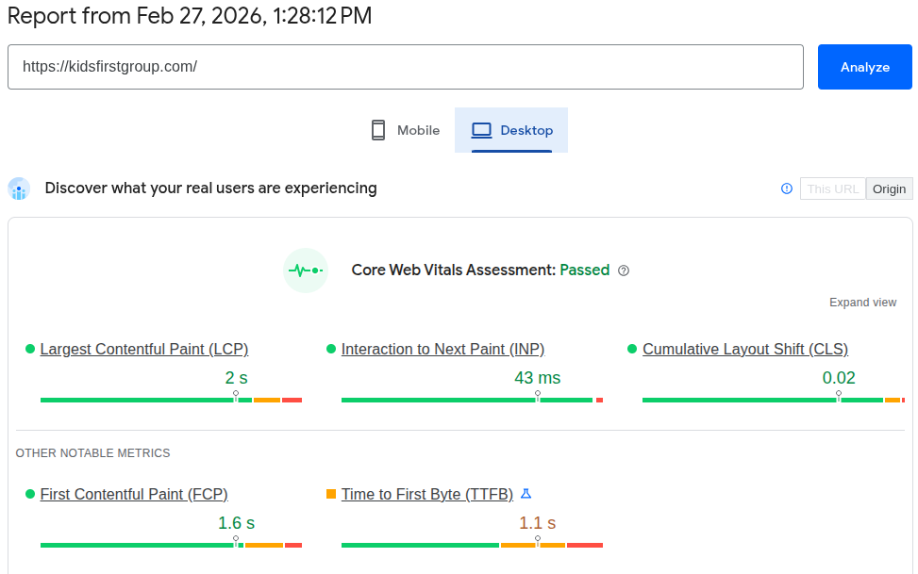
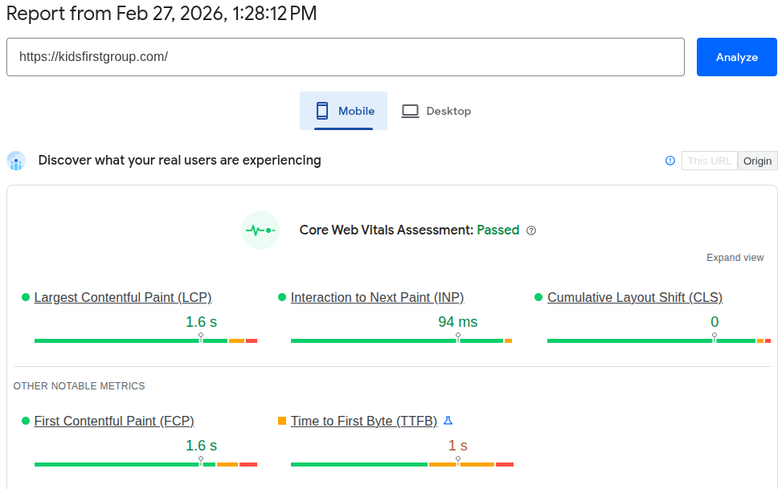

Home Page Performance Report:
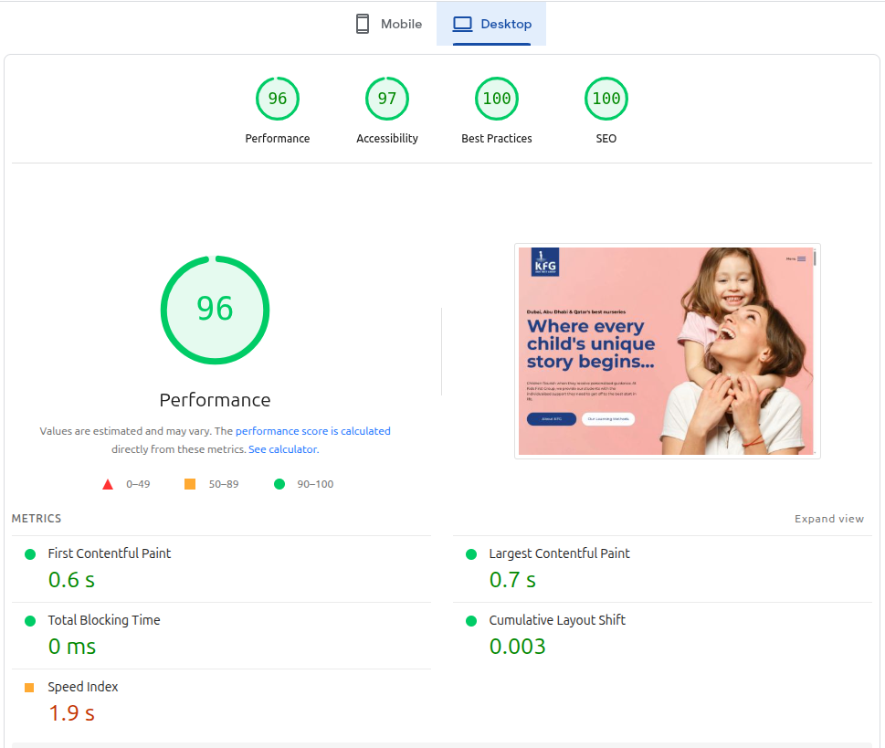
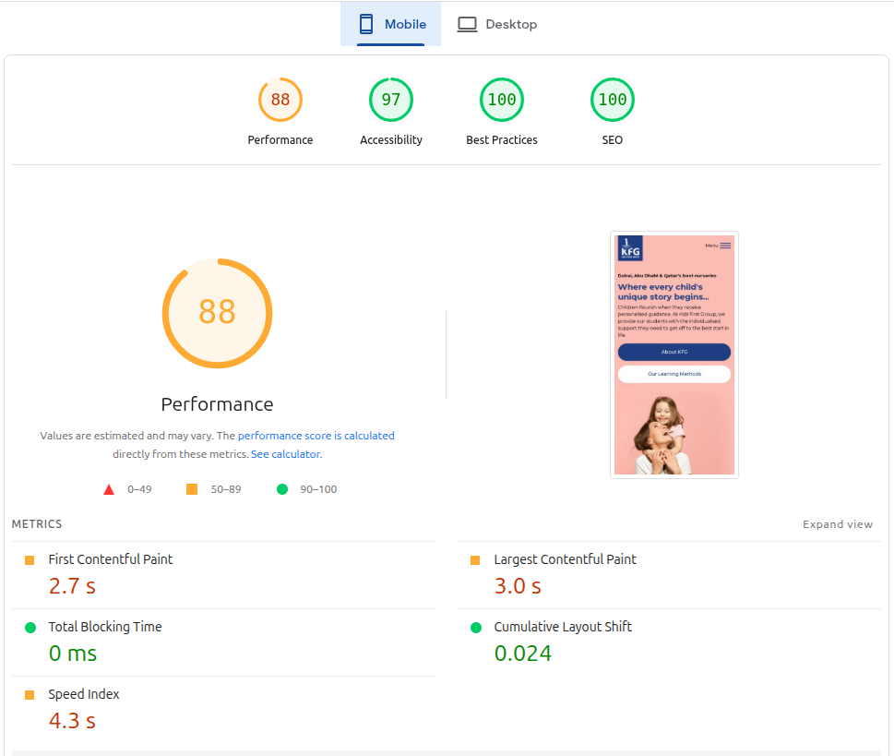

3. TECHNICAL SEO AUDIT
This section covers all technical issues discovered during the crawl and manual review. Each issue is classified by priority and includes the root cause, SEO impact, and specific fix required.

3.1 Critical Issues
ISSUE T-1: Zero Structured Data / Schema Markup for 35+ Locations
The site has no structured data markup. For a group operating 35+ nurseries across multiple brands and cities, this is a critical missed opportunity. Missing schema types include:
- LocalBusiness / ChildCare schema for each of the 35+ individual branch locations
- EducationalOrganization schema for each brand (Redwood, Odyssey, etc.)
- Organization schema for the parent company (Kids First Group)
- Product (or Service) schema for programs and age groups
- BreadcrumbList schema for navigation hierarchy
- FAQPage schema for parent information content
- AggregateRating / Review schema for testimonials
- Brand schema linking individual nurseries to the parent group
- Impact: No eligibility for rich snippets, knowledge panels, or enhanced Local Pack features for any of the 35+ locations. Competitors with schema markup get significantly higher click-through rates.
- Fix: Implement JSON-LD schema on each page type, with priority on creating individual LocalBusiness schema for every branch. Validate using Google's Structured Data Testing Tool.
ISSUE T-2: Missing Individual Location Pages for All 35+ Branches
The website prominently mentions "35 Nurseries" across Dubai, Abu Dhabi, and Doha, but provides zero individual pages for any of these locations. There is no way for a parent in JBR, The Springs, or West Bay to find information specific to the KFG nursery in their area.
- Impact: Complete invisibility for the most important type of search queries: "nursery near me," "nursery in [specific area]," and "[area] nursery." This represents a complete loss of the primary enrollment channel for a group with 35+ locations.
- Fix: Create 35+ unique, high-quality location pages immediately. Each page must include:
  - Unique 600–1000+ word content describing the specific campus
  - Local neighborhood details and proximity to landmarks
  - Which brand operates at that location (Redwood, Odyssey, etc.)
  - Brand-specific curriculum information adapted to that branch
  - Staff highlights for that branch
  - Parent testimonials specific to that location
  - Local FAQs addressing area-specific parent questions
  - Embedded Google Map with correct pin
  - Complete NAP information
  - LocalBusiness schema markup linking to parent brand
ISSUE T-3: Thin Brand Pages (Redwood, Odyssey, etc.)
The site has pages for individual brands like Redwood Montessori and Odyssey Nursery, but these are thin and lack depth. They provide overviews but no detailed information on curriculum, age groups, or specific locations.
- Impact: Lost opportunities to rank for brand-specific queries and curriculum-based searches. Individual brand websites (e.g., theredwoodnursery.com) may outrank the group site for their own brand names.
- Fix: Expand each brand page to comprehensive hubs with:
  - 1000–1500+ words on the brand's educational philosophy
  - Detailed curriculum information (Montessori, Reggio Emilia, EYFS, IB PYP)
  - Age group/program details with dedicated sections
  - Links to all individual location pages for that brand
  - Staff philosophy and approach
  - Testimonials specific to that brand
  - Brand-specific schema markup

3.2 High Priority Issues
ISSUE T-4: Missing Commercial Landing Pages (Fees/Admissions)
There is no dedicated page for nursery fees, pricing, or admissions process across the group. This is a critical gap for capturing high-intent commercial traffic.
- Impact: Loss of parents searching "nursery fees Dubai," "nursery costs," "admissions process Dubai nurseries."
- Fix: Create a dedicated Fees & Admissions page with transparent information, brand-by-brand comparisons, and clear CTAs.
ISSUE T-5: No XML Sitemap Optimization
While a default sitemap may exist, there's no evidence of a properly segmented, submitted sitemap optimized for the site's complex structure (brands + locations).
- Fix: Generate a comprehensive XML sitemap with separate entries for brand pages, location pages, and future blog content. Submit to Google Search Console.
ISSUE T-6: No Robots.txt Optimization
No custom robots.txt directives were identified. The file should explicitly reference the sitemap location.
- Fix: Create and upload a robots.txt file with appropriate directives.
ISSUE T-7: Limited Internal Linking Strategy
Pages operate in silos. Brand pages don't link to specific locations. Location pages don't exist yet. Testimonials don't link to specific branches. This prevents link equity flow and topical understanding.
- Fix: Implement robust internal linking once location pages are created, connecting:
  - Homepage → Brand pages → Location pages
  - Blog content → Relevant brand pages → Specific locations
  - Testimonials → Specific branches
ISSUE T-8: Missing H1 Tags or Improper Structure
Review of key pages reveals inconsistent H1 implementation:
- Homepage H1 is "Dubai, Abu Dhabi & Qatar's best nurseries" — good but could be stronger
- Brand pages lack clear, unique H1 tags focusing on the specific educational approach
- No location pages exist to evaluate H1 structure
- Fix: Ensure each page has a single, unique, keyword-rich H1 tag. For brand pages: "Montessori Nursery in Dubai | Redwood by Kids First Group."
ISSUE T-9: Canonical Tag Review
S. No | Address | Occurrences | Indexability | Canonical URL
1 | https://kidsfirstgroup.com/ | 1 | Indexable | https://kidsfirstgroup.com/
2 | https://kidsfirstgroup.com/contact-us/ | 1 | Indexable | https://kidsfirstgroup.com/contact-us/
3 | https://kidsfirstgroup.com/our-team/ | 1 | Indexable | https://kidsfirstgroup.com/our-team/
4 | https://kidsfirstgroup.com/about-us/ | 1 | Indexable | https://kidsfirstgroup.com/about-us/
5 | https://kidsfirstgroup.com/redwood-center-of-excellence-to-open-in-jubail-island-abu-dhabi/ | 1 | Indexable | https://kidsfirstgroup.com/redwood-center-of-excellence-to-open-in-jubail-island-abu-dhabi/
6 | https://kidsfirstgroup.com/redwood-center-of-excellence-receives-the-international-baccalaureate-pyp-accreditation/ | 1 | Indexable | https://kidsfirstgroup.com/redwood-center-of-excellence-receives-the-international-baccalaureate-pyp-accreditation/
7 | https://kidsfirstgroup.com/terms-conditions/ | 1 | Indexable | https://kidsfirstgroup.com/terms-conditions/
8 | https://kidsfirstgroup.com/cookie-policy/ | 1 | Indexable | https://kidsfirstgroup.com/cookie-policy/
9 | https://kidsfirstgroup.com/our-nurseries/ | 1 | Indexable | https://kidsfirstgroup.com/our-nurseries/
10 | https://kidsfirstgroup.com/our-approaches/ | 1 | Indexable | https://kidsfirstgroup.com/our-approaches/
11 | https://kidsfirstgroup.com/blog/ | 1 | Indexable | https://kidsfirstgroup.com/blog/
12 | https://kidsfirstgroup.com/careers/ | 1 | Indexable | https://kidsfirstgroup.com/careers/
13 | https://kidsfirstgroup.com/privacy-policy/ | 1 | Indexable | https://kidsfirstgroup.com/privacy-policy/
14 | https://kidsfirstgroup.com/health-safety/ | 1 | Indexable | https://kidsfirstgroup.com/health-safety/
15 | https://kidsfirstgroup.com/unlocking-the-future-setting-the-momentum-for-future-ready-children/ | 1 | Indexable | https://kidsfirstgroup.com/unlocking-the-future-setting-the-momentum-for-future-ready-children/
16 | https://kidsfirstgroup.com/celebrate-the-journey-the-power-of-embracing-mistakes/ | 1 | Indexable | https://kidsfirstgroup.com/celebrate-the-journey-the-power-of-embracing-mistakes/
17 | https://kidsfirstgroup.com/how-second-language-learning-changes-children/ | 1 | Indexable | https://kidsfirstgroup.com/how-second-language-learning-changes-children/
18 | https://kidsfirstgroup.com/3-ways-to-stay-engaged-with-your-childs-nursery-life/ | 1 | Indexable | https://kidsfirstgroup.com/3-ways-to-stay-engaged-with-your-childs-nursery-life/
19 | https://kidsfirstgroup.com/category/news-and-articles/ | 1 | Indexable | https://kidsfirstgroup.com/category/news-and-articles/
20 | https://kidsfirstgroup.com/how-stem-and-montessori-work-together/ | 1 | Indexable | https://kidsfirstgroup.com/how-stem-and-montessori-work-together/
21 | https://kidsfirstgroup.com/blog/page/2/ | 1 | Indexable | https://kidsfirstgroup.com/blog/page/2/
22 | https://kidsfirstgroup.com/embrace-the-journey-discovering-the-best-age-for-school-beginnings/ | 1 | Indexable | https://kidsfirstgroup.com/embrace-the-journey-discovering-the-best-age-for-school-beginnings/
23 | https://kidsfirstgroup.com/how-to-settle-your-little-one-into-nursery/ | 1 | Indexable | https://kidsfirstgroup.com/how-to-settle-your-little-one-into-nursery/
24 | https://kidsfirstgroup.com/category/article-2/ | 1 | Indexable | https://kidsfirstgroup.com/category/article-2/
25 | https://kidsfirstgroup.com/importance-of-sleep-for-children/ | 1 | Indexable | https://kidsfirstgroup.com/importance-of-sleep-for-children/
26 | https://kidsfirstgroup.com/blog/page/3/ | 1 | Indexable | https://kidsfirstgroup.com/blog/page/3/
27 | https://kidsfirstgroup.com/redwood-montessori-nursery-branch-opening-soon-in-al-marina-abu-dhabi/ | 1 | Indexable | https://kidsfirstgroup.com/redwood-montessori-nursery-branch-opening-soon-in-al-marina-abu-dhabi/
28 | https://kidsfirstgroup.com/redwood-montessori-nursery-receives-montessori-accreditation/ | 1 | Indexable | https://kidsfirstgroup.com/redwood-montessori-nursery-receives-montessori-accreditation/
29 | https://kidsfirstgroup.com/world-childrens-day-2019/ | 1 | Indexable | https://kidsfirstgroup.com/world-childrens-day-2019/
30 | https://kidsfirstgroup.com/willow-childrens-nursery-to-open-in-one-central-dubai/ | 1 | Indexable | https://kidsfirstgroup.com/willow-childrens-nursery-to-open-in-one-central-dubai/
31 | https://kidsfirstgroup.com/odyssey-nursery-opens-new-branch-in-dubai/ | 1 | Indexable | https://kidsfirstgroup.com/odyssey-nursery-opens-new-branch-in-dubai/
32 | https://kidsfirstgroup.com/the-power-of-peace/ | 1 | Indexable | https://kidsfirstgroup.com/the-power-of-peace/
33 | https://kidsfirstgroup.com/redwood-nursery-to-open-in-dafna-soon/ | 1 | Indexable | https://kidsfirstgroup.com/redwood-nursery-to-open-in-dafna-soon/
34 | https://kidsfirstgroup.com/a-personalised-learning-approach-for-ages-4-6/ | 1 | Indexable | https://kidsfirstgroup.com/a-personalised-learning-approach-for-ages-4-6/
35 | https://kidsfirstgroup.com/cultivating-confidence-and-independence-in-children-through-affirmation/ | 1 | Indexable | https://kidsfirstgroup.com/cultivating-confidence-and-independence-in-children-through-affirmation/
36 | https://kidsfirstgroup.com/welcome-to-redwood-center-of-excellence/ | 1 | Indexable | https://kidsfirstgroup.com/welcome-to-redwood-center-of-excellence/
37 | https://kidsfirstgroup.com/category/article-2/page/2/ | 1 | Indexable | https://kidsfirstgroup.com/category/article-2/page/2/
38 | https://kidsfirstgroup.com/introducing-kfg-supermum/ | 1 | Indexable | https://kidsfirstgroup.com/introducing-kfg-supermum/
39 | https://kidsfirstgroup.com/celebrating-the-power-of-independent-play/ | 1 | Indexable | https://kidsfirstgroup.com/celebrating-the-power-of-independent-play/
40 | https://kidsfirstgroup.com/embracing-the-art-of-sharing/ | 1 | Indexable | https://kidsfirstgroup.com/embracing-the-art-of-sharing/
41 | https://kidsfirstgroup.com/kfgs-immersive-summer-camps-2021/ | 1 | Indexable | https://kidsfirstgroup.com/kfgs-immersive-summer-camps-2021/
42 | https://kidsfirstgroup.com/kids-first-group-receives-the-great-place-to-work-certificate/ | 1 | Indexable | https://kidsfirstgroup.com/kids-first-group-receives-the-great-place-to-work-certificate/
43 | https://kidsfirstgroup.com/a-new-redwood-montessori-nursery-branch-set-to-open-in-yas-bay-abu-dhabi/ | 1 | Indexable | https://kidsfirstgroup.com/a-new-redwood-montessori-nursery-branch-set-to-open-in-yas-bay-abu-dhabi/
44 | https://kidsfirstgroup.com/redwood-montessori-nursery-set-to-open-a-new-branch-in-al-furjan-dubai/ | 1 | Indexable | https://kidsfirstgroup.com/redwood-montessori-nursery-set-to-open-a-new-branch-in-al-furjan-dubai/

4. ON-PAGE SEO ANALYSIS
This section evaluates the quality and optimization of the site's existing content. Due to the technical SPA structure, a traditional page-by-page analysis is difficult. Instead, this evaluates the "content modules" that exist within the single URL.
4.1 Page-by-Page Assessment

Page | Title | H1 | Meta Desc | Notes
Homepage | ⚠️ Too long | ✅ Good | ⚠️ Generic | Title lacks strong commercial keywords like "best nursery group Dubai." H1 strong but missing links to specific brands/locations.
Our Nurseries | ⚠️ Moderate | ✅ Good | ⚠️ Generic | Good overview but no links to individual branch pages (which don't exist). Missed opportunity to showcase 35+ locations.
Redwood Montessori | ⚠️ Thin | ✅ OK | ⚠️ Generic | Thin content, lacks depth on Montessori philosophy, age groups, and specific locations.
Odyssey Nursery | ⚠️ Thin | ✅ OK | ⚠️ Generic | Similar issues, minimal information on Reggio Emilia approach and branch locations.
About Us | ✅ OK | ✅ OK | ✅ OK | Good brand storytelling but lacks links to individual brands and locations.
Testimonials | ⚠️ Generic | ✅ OK | ⚠️ Generic | Lacks schema markup, no connection to specific branches or brands.
Careers | ✅ OK | ✅ OK | ✅ OK | Functional careers page but no SEO optimization for recruitment keywords.
Contact Us | ⚠️ Generic | ✅ OK | ⚠️ Generic | Missing location-specific contact information for 35+ branches.

Key Observations

1. Title Tag Optimization

The homepage title is brand-heavy and lacks strong commercial keywords such as "best nursery group Dubai," "nursery fees," or location-specific terms.

Primary service keywords like "Montessori nursery," "Reggio Emilia Dubai," "EYFS curriculum," or "preschool [area]" are not consistently used across brand pages.

No location-based pages exist, so there is no standardized keyword structure for individual branches (e.g., "Nursery in JBR | Redwood by KFG").

Seasonal or campaign pages are absent, missing opportunities to target "summer camp Dubai" or "nursery open days."

The site prioritizes corporate brand messaging over search visibility, significantly reducing ranking potential for high-intent queries that parents actually search for.

2. H1 Structure Issues

The homepage H1 ("Dubai, Abu Dhabi & Qatar's best nurseries") is strong but could be more keyword-focused. Other pages lack consistent H1 implementation.

Brand pages (Redwood, Odyssey) use H1 tags effectively but the content beneath is thin, missing the depth needed to support the H1's promise.

No location pages exist to evaluate H1 structure for local SEO.

Some section headings are marketing-driven ("Focusing On The Child") rather than keyword-focused ("Montessori Program for Toddlers (1-3 Years)").

Best practice:

One clear, keyword-focused H1 per page (homepage, brand pages, and future location pages)

Structured H2 and H3 subheadings supporting semantic depth on dedicated pages

Topic-driven headings rather than emotional slogans for indexable content

3. Meta Description Optimization

Multiple pages use generic meta descriptions lacking strong commercial triggers, location modifiers, or clear unique selling propositions (USPs).

There is no differentiation from competitors in meta data (e.g., no mention of "35 nurseries," "multiple curricula," or "14+ years experience").

Parent-focused reassurance signals (safety, global educator standards, diverse curriculum options) are missing.

There is no enrollment-focused CTA such as "Book a Tour" or "Find a Nursery Near You" in the meta data.

Meta descriptions should (for each new dedicated page):

Include primary service + location + brand (e.g., "Montessori Nursery in JBR | Redwood by Kids First Group")

Reinforce trust ("14+ years," "35 nurseries," "globally recognised curricula")

Add emotional reassurance for parents ("nurturing potential," "future-ready learners")

Include a clear CTA (e.g., "Schedule a Tour Today")
4.2 Content Depth Assessment
KFG's content structure is headquarters-heavy, with all focus on the corporate group rather than the individual nurseries that parents actually search for.

Content Imbalance
- Homepage focuses on corporate messaging rather than directing users to specific brands and locations. It should be streamlined to provide a group overview with clear hubs to individual brand and location pages.
- Brand pages for Redwood, Odyssey, and others are currently thin overviews that lack depth. Each should be expanded into comprehensive brand hubs with 1000+ words covering curriculum, philosophy, age groups, and links to specific branches.
- Location pages are completely absent despite the group operating 35+ nurseries. This is a critical gap that must be addressed by creating 35+ unique, rich location pages with local content, staff highlights, and area-specific information.
- Curriculum pages are not present, missing the opportunity to target parents searching for specific educational approaches like Montessori, Reggio Emilia, EYFS, or IB PYP. Dedicated pages should be created for each curriculum offered across the group.
- Blog section does not exist, resulting in lost informational traffic and reduced topical authority. A blog with 20–30+ articles targeting parent research queries should be launched.
- Admissions and fees page is not present, missing high-intent commercial traffic. A dedicated page with fee information, admission process, and clear CTAs is needed.
- Location pages represent a critical gap with zero pages created for any of the 35+ branches, resulting in complete loss of local search visibility and "near me" traffic.

Location Pages – Major Gap
Current issues:
The upcoming Abu Dhabi branch is a major growth opportunity, but the current approach severely limits its visibility:
- No dedicated pages exist for any of the 35+ nursery locations across Dubai, Abu Dhabi, and Doha.
- The "Our nurseries & environments" section provides a brand overview but no links to individual branches.
- No local content about specific neighborhoods (JBR, The Springs, West Bay, etc.), family amenities, or proximity to landmarks.
- No area-specific keyword targeting (e.g., "nursery in JBR," "Redwood Montessori The Springs," "Odyssey nursery Abu Dhabi").
- No branch-specific contact information, staff highlights, or local testimonials.
- No local FAQs for parents in specific areas.
- No LocalBusiness schema markup for any location, despite having 35+ branches.
Google's Helpful Content system deprioritizes pages that:
- Lack unique local value and neighborhood-specific information
- Do not demonstrate topical authority for specific service areas
- Fail to provide dedicated, substantive content for each physical location
- Rely on corporate overviews rather than local relevance

Program/Age Group Pages — Major Gap
Current issues:
- Age groups (Baby 0-1, Toddler 1-3, Child 3-5) are summarized in brief paragraphs on the homepage only.
- No dedicated URLs for age-specific programs exist for any brand.
- Limited detail on curriculum, daily routines, learning outcomes, or developmental milestones.
- No teacher qualification details per age group.
- No age-specific parent guides or resources.
- Brand-specific approaches (Montessori, Reggio Emilia) are not elaborated for each developmental stage.
- No internal linking from age group mentions to specific brand pages or locations offering those programs.

Internal Linking Depth
- Limited contextual linking: Age group sections don't link to relevant brand pages (Redwood, Odyssey) or to specific locations. Brand pages don't link to individual branches (which don't exist yet).
- Anchor text is mostly generic: Where links exist, they use phrases like "Learn More" or "Click below" rather than keyword-rich anchor text that improves relevance.
- No blog hub to support internal authority flow and create topic clusters around different curricula (Montessori, Reggio, EYFS), child development, and location-specific parenting guides.
- Location pages not present to interlink with brand content, age group programs, or curriculum information, creating a completely flat site structure with no local depth.
- Brand pages operate in isolation with no connections between Redwood, Odyssey, and other KFG offerings, missing opportunities for cross-linking and topic clustering.
4.3 Overall On-Page SEO Health Summary

Strengths
✓ Strong corporate brand authority (14+ years)
✓ Clear group value proposition
✓ Multiple specialized brand pages (foundation present)
✓ Good testimonial social proof
✓ Clean, professional design

Weaknesses
✖ No individual location pages for 35+ branches (Critical)
✖ Thin brand page content (Critical)
✖ No structured data markup
✖ No blog ecosystem
✖ Missing commercial pages (fees/admissions)
✖ Generic meta data across pages
✖ Weak keyword optimization depth
✖ No internal linking between brands and locations
✖ Brand-specific keywords not fully exploited

5. COMPETITIVE LANDSCAPE ANALYSIS
Kids First Group is the largest nursery group in the UAE/Qatar region, with 35+ nurseries across multiple specialized brands. However, individual competitors with smaller scale often outperform KFG in organic search due to better content depth and local optimization.
5.1 Competitor Content Comparison

Competitor | Blog | Fee Page | Schema | Locations | Est. Pages | Key Advantage
Kids First Group | ⚠️ Limited | ❌ No | ❌ No | 0 of 35+ | ~30–35 | Scale + brand portfolio
Blossom Nursery | ✅ Yes | ✅ Yes | ✅ Yes | 10+ (rich) | ~90+ | Large-scale premium + extensive content
JINS | ✅ Yes | ✅ Yes | ✅ Yes | 5 (rich) | ~80+ | Scale + content depth
British Orchard | ✅ Yes | ✅ Yes | ✅ Yes | 10+ (rich) | ~100+ | Massive footprint + comprehensive content
Children's Oasis | ✅ Yes | ⚠️ Partial | ⚠️ Basic | 2 (rich) | ~40+ | Local authority
Little London Nursery | ⚠️ Limited | ❌ No | ❌ No | 1 (rich) | ~30+ | Strong brand positioning, single location focus
Yellow Kite Nursery | ✅ Yes | ✅ Yes | ✅ Yes | 1 (rich) | ~40+ | SEO content + Reggio Emilia focus
Toddler Town | ✅ Yes | ✅ Yes | ✅ Yes | 2 (rich) | ~50+ | Award branding + content depth

5.2 Key Competitor Insight
Overview
Kids First Group has an unparalleled advantage in scale and brand portfolio, operating 35+ nurseries across the UAE and Qatar under specialized brands like Redwood Montessori and Odyssey Nursery. However, individual competitors with smaller footprints are outperforming KFG in organic search because they invest in deep content per location and per curriculum. KFG's greatest asset—its 35+ nurseries—is completely invisible to search engines.
Strategic Observations
1. Content Depth Gap
Individual nursery brands (even those owned by KFG) often have more detailed content on their standalone sites than the KFG corporate site provides. Competitors like Blossom Nursery and British Orchard maintain dedicated blog sections, detailed curriculum pages, separate fee pages, and expanded location pages for each branch. KFG's entire content footprint is compressed onto a corporate site with thin brand pages and zero location pages, severely limiting its ability to rank for the wide range of terms parents search for.
2. Local SEO Execution (Critical Gap)
KFG has 35+ locations but zero individual pages for any of them. This is the single biggest missed opportunity.
- Competitors with multiple branches invest heavily in unique, rich location content per branch, including:
  - Individual optimized pages per location
  - Location-specific keyword targeting (e.g., "nursery in JBR," "Montessori The Springs")
  - Strong Google Business Profile optimization
  - Higher review volumes per branch
  - Consistent Local Pack visibility
- KFG currently has no dedicated location pages, resulting in zero visibility for parents searching for nurseries in specific areas across Dubai, Abu Dhabi, and Doha, and losing the chance to capture "near me" traffic at the moment of decision.
3. Commercial Intent Capture
Competitors rank for high-conversion keywords that drive enrollment. KFG lacks dedicated pages targeting these queries:
- nursery fees Dubai
- best nursery in Dubai
- nursery admission Dubai
- Montessori nursery cost
- Reggio Emilia nursery fees
KFG currently has no dedicated landing pages targeting these high-intent searches, limiting organic lead generation and forcing reliance on brand recognition alone, despite having the most comprehensive offering in the region.
4. Schema Implementation
Leading competitors utilize structured data comprehensively to enhance their SERP presence. KFG has zero schema markup, missing rich result opportunities for all 35+ locations:
- LocalBusiness schema for each branch (critical for local SEO)
- EducationalOrganization schema for each brand with curriculum details
- FAQ schema for parent information
- Review schema for testimonials
- Event schema for seasonal camps or open days
- Brand schema linking individual nurseries to the parent group
This enhances competitor visibility in rich results and improves their click-through rates from SERPs, while KFG remains invisible.
5. Brand Trust & Authority Signals
Top-performing nurseries strengthen credibility through dedicated content that KFG currently lacks at the brand level:
- Awards & accreditations pages: Detailed information about KHDA approvals, Montessori certifications, and international accreditations
- Staff credentials and expertise pages: Bios of leadership and educators across brands, highlighting specialized training
- Testimonials & review-rich content: Video case studies and parent stories with schema, connected to specific branches
- Strong backlink profiles: Acquired from IB education sites, parenting platforms, and local news for individual brands
These signals increase both search engine trust and parent confidence during the decision process, an area where KFG has significant room for growth despite its scale advantage.

5.3 Keyword Gap Analysis
Based on SERP analysis, the following high-value keywords have significant search volume but zero Redwood CoE content:
High-Intent Commercial Keywords

Keyword Opportunity | Est. Volume | Current Ranking | Content Needed
best nursery in Dubai | High | Not ranking | Authority landing page + brand comparisons
nursery fees Dubai 2026 | High | No page exists | Dedicated fees page with brand breakdown
nursery near me | High | Not ranking | 35+ enriched location pages
Montessori nursery Dubai | High | Weak (Redwood page) | Expanded Redwood hub
Reggio Emilia nursery Dubai | Medium | Weak (Odyssey page) | Expanded Odyssey hub
British nursery Dubai | High | Not ranking | UK curriculum brand page
nursery admission Dubai | High | Not ranking | Admissions guide page

Local Search Keyword Gaps

Keyword Opportunity | Est. Volume | Current Ranking | Content Needed
nursery in JBR | High | Not ranking | Redwood/Odyssey JBR location page
nursery in The Springs | High | Not ranking | Location page for relevant brand
nursery in Palm Jumeirah | High | Not ranking | Location page
nursery in Arabian Ranches | Medium | Not ranking | Location page
nursery in West Bay (Doha) | High | Not ranking | Location page for Qatar branch
nursery near me [each area] | High | Not ranking | All 35+ location pages optimized
Informational & Parent Research Keywords

Keyword Opportunity | Est. Volume | Current Ranking | Content Needed
Montessori vs Reggio Emilia | Medium | Not ranking | Comparison blog post
what is Montessori method | Medium | Not ranking | In-depth guide
EYFS curriculum explained | Medium | Not ranking | Educational blog
when to start nursery UAE | Medium | Not ranking | Parenting advice blog
how to choose a nursery Dubai | Medium | Not ranking | Pillar blog post

Strategic Keyword Gap Summary
- KFG primarily ranks for branded searches only
- Competitors dominate commercial + local + informational keywords
- No location pages = complete loss of "near me" traffic for 35+ branches
- Thin brand pages = loss of curriculum-based searches
- No structured fee page = loss of commercial conversion queries
- Lack of blog ecosystem = reduced topical authority and lost informational traffic
- Portfolio of premium educational approaches (Montessori, Reggio, EYFS, IB) completely unexploited

6. LOCAL SEO ASSESSMENT
For a group with 35+ nurseries across multiple cities, local SEO is the single most important channel for enrollment. Currently, KFG's local search presence is almost entirely dependent on Google Business Profiles, with no support from the corporate website.
6.1 Google Business Profile Audit
A search for individual KFG nurseries (e.g., "Redwood Nursery JBR") shows various Google Business Profiles (GBPs) for branches, managed under different brand names. This is positive, but significant optimization opportunities exist:
- Profile verification and optimization levels vary significantly by branch
- Primary categories are inconsistent (Nursery School, Montessori School, etc.)
- Business descriptions lack strong local keyword targeting
- Review counts vary widely (5–100+ per branch)
- Review response strategy appears inconsistent across the group
- Google Posts activity is limited
- Photo counts vary by branch
- Q&A sections not actively managed across most profiles
Critical Gap: The website provides no links to these GBP profiles, and the profiles have no authoritative location-specific pages on the website to link back to. This breaks the local SEO authority loop.
6.2 NAP Consistency Check
NAP (Name, Address, Phone) consistency should be audited across all 35+ branches for:
- Google Business Profile (each branch)
- Bayut.com nursery listings
- Edarabia.com listings
- EdCare.ae listings
- NurseryinDubai.com listings
- Facebook Pages
- Instagram profiles
- Local directories in each city
Recommended Action: Publish complete, consistent NAP information for all 35+ branches on their new, dedicated location pages. This creates an authoritative source of truth for Google.
6.3 Review Strategy Assessment
- Online reviews are a significant local ranking factor and the primary trust signal for parents choosing a nursery. A group-wide review acquisition and response strategy should be implemented across all 35+ branches.
- Review count varies widely from 5 to 100+ per branch, with a 50–100+ gap for many branches compared to top competitors.
- Average rating is generally strong at 4.5★+ where present, but this high standard must be maintained consistently across all locations.
- A structured campaign is needed to close the 50–100+ review volume gap with top competitors within 12 months.
- Review response rate is currently inconsistent across branches; the target should be 100% response within 48 hours for all reviews.
- Response quality lacks keyword-rich, personalized content that reinforces brand positioning and local relevance.
- Negative reviews are addressed inconsistently, with varying depth, reassurance, and structured service recovery messaging.
- Review growth rate varies significantly by branch, indicating that a coordinated, group-wide review generation strategy is needed.
- A group-wide review strategy should be implemented with standardized response templates, staff training, and regular monitoring to ensure consistency and quality across all 35+ locations.

7. CONTENT STRATEGY RECOMMENDATIONS
Overview
Kids First Group has the strongest asset in the region—35+ nurseries across premium brands—but its website does not reflect this scale. The content strategy must shift from corporate messaging to a location-first, brand-supported architecture that makes every nursery visible to parents searching locally.

7.1 Phase 1: Foundation Content
1) Individual Location Pages for All 35+ Branches (CRITICAL)
This is the highest priority initiative. Create a dedicated page for every single nursery branch, organized by brand and area:
- URL structure: /nursery/[brand]/[area]/ (e.g., /nursery/redwood/jbr/)
- Each page: 600–1000+ words unique content including:
- Local neighborhood details and proximity to landmarks
- Brand-specific curriculum adapted to that branch
- Staff highlights with photos and credentials
- Parent testimonials specific to that location
- Local FAQs addressing area-specific parent questions
- Embedded Google Map with correct pin
- Complete NAP information
- LocalBusiness schema markup
- Photos of the specific campus
Target keywords:
- nursery in [area]
- [brand] nursery [area]
- nursery near me [area]
- best nursery [area]
2) Expanded Brand Hubs (5+ Brands)
Transform thin brand pages into comprehensive hubs:
- Redwood Montessori: Montessori philosophy, age groups (0–6), materials, teacher qualifications, KHDA approval, locations
- Odyssey Nursery: Reggio Emilia approach, child-led learning, environment as third teacher, locations
- Future brand pages for any additional educational approaches (EYFS, IB PYP, etc.)
Each brand hub: 1000–1500+ words with:
- Detailed curriculum explanation
- Age group/program breakdowns
- Links to all location pages for that brand
- Staff philosophy and approach
- Testimonials specific to that brand
- Brand-specific schema markup
3) Fees & Admissions Page
Create dedicated page targeting commercial queries with:
- Fee ranges by brand and location
- Admission process overview
- Required documents
- Age group enrollment criteria
- Sibling discounts and payment plans
- Clear CTAs for tours and inquiries
4) Curriculum Comparison Hub
Create a resource page comparing all educational approaches offered across KFG brands:
- Montessori vs. Reggio Emilia vs. EYFS vs. IB PYP
- Which brand is right for different child personalities
- How to choose based on educational philosophy
5) FAQ Hub with Structured Data
Create centralized FAQ page with FAQ schema addressing:
- Student-to-teacher ratios across brands
- Teacher qualifications and training
- KHDA accreditation status per brand
- Safety and security protocols
- Payment plans and fee structure
- Daily schedule and routines
- Meal plans and nutrition
- Parent communication and daily updates

7.2 Phase 2: Educational Blog Launch
Publish 2–4 posts monthly on strategic topics, cross-linking to relevant brands and locations:
1. Montessori vs. Reggio Emilia: Which is Right for Your Child?
- Compares two of KFG's flagship educational approaches, helping parents understand the differences in philosophy, classroom environment, and child outcomes
2. Understanding the EYFS Framework: A Guide for UAE Parents
- Explains the UK Early Years Foundation Stage curriculum, its 7 areas of learning, and how it prepares children for school
3. What is the IB Primary Years Programme?
- Introduces the International Baccalaureate PYP for early years, covering the 5 essential elements and transdisciplinary learning
4. How to Choose Between Different Nursery Curricula in Dubai
- A comprehensive guide comparing Montessori, Reggio Emilia, EYFS, and IB PYP to help parents make informed decisions
5. A Parent's Guide to Nurseries in JBR: Redwood, Odyssey & More
- Provides local insights for families in Jumeirah Beach Residence, highlighting KFG nurseries in the area and their unique offerings
6. Living in The Springs: Best Nurseries for Families
- A neighborhood guide for families in The Springs community, featuring KFG's nearby locations and family amenities
7. When to Start Nursery in UAE: Age-by-Age Guide
- Helps parents decide the right age to enroll based on developmental milestones and readiness signs
8. How to Prepare Your Child for Their First Day at Nursery
- Practical tips for parents to ease separation anxiety, build excitement, and ensure a smooth transition
9. Language Development in Toddlers: Milestones & Tips
- Covers key language milestones from 12 months to 3 years with at-home activities to support development
10. The Importance of Play-Based Learning in Early Years
- Explains how play-based approaches (used across Montessori, Reggio, and EYFS) build creativity, problem-solving, and social skills
11. Social-Emotional Development: What to Expect Ages 0-5
- Guides parents through emotional milestones, empathy development, and how nurseries support social skills
12. How Montessori Materials Support Cognitive Development
- Deep dive into specific Montessori materials (practical life, sensorial, language, mathematics) and their purpose
13. Family-Friendly Dubai Marina: Nurseries, Parks & More
- A comprehensive lifestyle guide for families in Dubai Marina, featuring KFG nurseries and family attractions
14. Living in West Bay, Doha: A Guide for Families
- Local insights for families in West Bay, Doha, highlighting KFG's Qatar locations and community amenities
15. Top Areas in Abu Dhabi for Families with Young Children
- A guide to family-friendly neighborhoods in Abu Dhabi, including Al Jubail Island, with information on nearby KFG nurseries
16. Complete Guide to Nurseries in Arabian Ranches
- A dedicated guide for families in Arabian Ranches, featuring KFG's nearby locations and community information

7.3 Phase 3: Authority Building (Month 6+)
1) Staff Credentials & Expertise Pages
Create dedicated pages showcasing the expertise across the group:
- Executive leadership bios with educational backgrounds
- Brand-specific educational directors
- Teacher qualification standards across the group
- Professional development and training programs
- Years of experience and specializations
2) Parent Success Stories & Case Studies
Transform testimonials into rich case studies:
- Video interviews with parents from different branches
- Before–after narratives of child development
- Stories of children transitioning to top schools
- Branch-specific success stories
- Photos with permission
3) Curriculum Deep-Dive Hubs
Create comprehensive resources for each educational approach:
- Montessori materials and their purposes
- Reggio Emilia project-based learning examples
- EYFS 7 areas of learning with practical examples
- IB PYP transdisciplinary themes in action
4) Seasonal & Event-Driven Content
- Summer Camp Guide (by brand and location)
- Winter Wonderland activities
- Ramadan & Eid programming
- Back-to-school preparation guides
- Open house events across branches
7.4 Phase 4: Monthly Implementation Timeline

Month | Key Deliverables
Month 1 | Create location page template, Blog posts (4), launch first 10 location pages (priority high-search areas), XML sitemap submission
Month 2 | Create next 3 location pages, Blog posts (4), expand Redwood brand hub, create fees page
Month 3 | Create next 3 location pages, Blog posts (4), expand Odyssey brand hub, FAQ hub, internal linking structure
Month 4 | Create next 3 location pages, Blog posts (4), implement schema on all pages, begin GBP optimization across all branches
Month 5 | Create next 3 location pages, Blog posts (4), create curriculum comparison hub, begin staff credentials pages
Month 6 | Create next 3 location pages, Blog posts (4), parent case studies, seasonal content (summer camp), review generation campaign launch

POST-OPTIMIZATION
Resolving the issues and implementing the recommended content strategy over a period of 6 to 9 months yields reasonable results, as shown in the following table.

Metric | Current State | Projected (6–9 mo.) | Impact
Indexed Pages | ~40–45 | 60–80+ | 3x keyword coverage
Technical Health | 3 critical issues | 0 critical issues | Crawl efficiency + trust
Organic Keyword Rankings | ~30–40 terms | 300–500+ terms | 10x search visibility
"Best nursery Dubai" | Not in Top 30 | Target: Top 10 | Flagship commercial query
Location-Specific Queries | Ranking for 0 of 35+ | All 35+ ranking | Direct enrollment pipeline
Brand-Specific Queries | Weak for 2 brands | Strong for all brands | Brand authority
Schema / Rich Results | Zero | Local Pack + FAQ + Reviews | Higher CTR for all branches
Blog / Content Pages | 27 Pages | 40–45+ articles | Long-tail traffic capture
Local Pack Visibility | Inconsistent | All 35+ branches optimized | Map visibility for parents
Monthly Organic Traffic | Baseline TBD | Target: 5–8x increase | Measurable enrollment growth

9. PRIORITIZED IMPLEMENTATION ROADMAP
Issues and recommendations are categorized into implementation waves based on effort and impact. The foundation work is prioritized to support all subsequent SEO efforts.
WAVE 1: Quick Wins (Week 1–2)

Priority | Task | Impact
CRITICAL | Create location page template and architecture | Enables all future local SEO work
CRITICAL | Add H1 tags to all pages | Corrects page topic signals
CRITICAL | Create and submit XML sitemap | Improved crawl efficiency
CRITICAL | Create robots.txt with sitemap reference | Proper crawl directives
HIGH | Optimize images (WebP, compression) | Core Web Vitals improvement
HIGH | Implement lazy loading | Page speed improvement

WAVE 2: Technical Foundation (Week 3–6)

Priority | Task | Impact
CRITICAL | Launch first 10 location pages (priority high-search areas like JBR, The Springs, Dubai Marina) | Unlocks local search traffic for key branches immediately
CRITICAL | Implement LocalBusiness schema on all new location pages | Enables Local Pack eligibility and rich results for each branch
CRITICAL | Expand Redwood Montessori brand hub with comprehensive curriculum details | Captures Montessori-specific searches and establishes brand authority
HIGH | Expand Odyssey Nursery brand hub with Reggio Emilia curriculum depth | Captures Reggio Emilia searches and strengthens brand presence
HIGH | Launch next 15 location pages (remaining Dubai and Abu Dhabi branches) | Expands local visibility across all major catchment areas
HIGH | Create comprehensive FAQ hub with schema markup | Answers parent questions directly in SERPs with rich results

WAVE 3: Content & Growth (Month 2–6)

Priority | Task | Impact
HIGH | Launch blog (4 posts/month) on curricula, parenting, and locations | 3–5x keyword coverage; establishes topical authority
HIGH | Optimize all 35+ Google Business Profiles | Improves Local Pack rankings for every branch
HIGH | Implement group-wide review generation campaign | Boosts local rankings and parent trust
MEDIUM | Create staff credentials and expertise pages | Builds E-E-A-T and people-focused trust signals
MEDIUM | Develop parent case studies and video testimonials per brand | Drives conversions through emotional content
MEDIUM | Create curriculum deep-dive hubs (Montessori, Reggio, EYFS, IB) | Positions KFG as authority on multiple approaches
MEDIUM | Launch neighborhood guides for key areas (JBR, The Springs, West Bay) | Captures hyper-local search traffic
LOW | Seasonal content (summer camps, holiday programs, open days) | Drives time-sensitive traffic spikes

10. NEXT STEPS
This audit provides a roadmap for improving Kids First Group's organic search presence across its 35+ nurseries and multiple brands. The findings are prioritized to address the highest-impact, lowest-effort items right away, while longer-term content and local SEO initiatives are planned and carried out in the months ahead.
Recommended Immediate Actions
- Schedule kick-off meeting with stakeholders from each brand (Redwood, Odyssey, etc.) to align on priorities and location page rollout
- Implement Wave 1 quick wins (location page template, H1 tags, sitemap, robots.txt, image optimization)
- Obtain Google Search Console and Google Analytics access for baseline traffic data
- Set up rank tracking for 100–150 target keywords (brand terms, location terms, commercial terms)
- Begin Wave 2 technical foundation work (first 10 location pages, brand hub expansions)
- Develop content calendar for blog launch and brand page enhancements
- Create location page tracking system for monitoring branch-specific performance
Ongoing Monitoring & Reporting
We recommend monthly reporting on the following KPIs to track progress and demonstrate ROI:
- Organic traffic (Google Analytics) segmented by brand and location where possible
- Keyword ranking positions across target queries (commercial, local, informational, brand-specific)
- Google Business Profile views, clicks, and direction requests per branch (starting with priority locations)
- Core Web Vitals scores (monthly PageSpeed Insights checks)
- Indexed page count and crawl health via Search Console
- Inquiry/tour booking conversions attributed to organic search (requires form tracking setup)
- Review count and rating trends across all 35+ branches (aggregated and by location)
- Monthly performance report covering traffic growth, technical health, ranking improvements, and conversion summary

Month \ Week | Week 1 | Week 2 | Week 3 | Week 4
Month 1 | Location page content, New blog content, Backlink Content | New blog content, Backlink submission content | Location page content, New blog content, Fees page | New blog content, Guest post approach content
Month 2 | Location page content, New blog content, Main commercial pages content | New blog content, Staff Credentials & Expertise Pages content | Location page content, New blog content, Case studies & testimonials | New blog content, Backlink submission content, Guest post approach content
Month 3 | Location page content, New blog content, Parent success stories content, Staff profiles | Location page content, New blog content, Guest post approach content | Location page content, New blog content, Parent success stories content | New blog content, Article submission content, and FAQ content
Month 4 | Location page content, Main commercial pages content, New blog content, | Location page content, New blog content, FAQ content, | Location page content, New blog content, Guest post approach content | Location page content, New blog content, Seasonal & event Content
Month 5 | Location page content, Community engagement content, New blog content | Guest post approach content, Backlink submission content, New blog content | Location page content, New blog content, Main commercial pages content | New blog content, Parent success stories content, French pages Content
Month 6 | Location page content, New blog content, FAQ content, Arabic pages | New blog content, Community engagement content | Location page content, New blog content, Guest post approach content, | Location page content, New blog content, Seasonal & event Content

